
DS7006 2526 (T1)
Quantitative data analyst
Coursework 1 (Exercise Portfolio)

Name: Abdulhannan
Student ID: u2828994
Submitted to : yang li
All sessions
Session :1 3
Task 1: - 3
Task 3: - 4
Task 4: - 5
Task 5 6
Task 6 7
Task 7: - 8
Session 3 9
Task 1: - 9
Task 2: 10
Task 3 10
Task 4: - 11
Task 5: 12
Task 6: 13
Reflection 14
Session 4: - 14
Task1 15
Task 2 17
Task 3 18
Task4 19
Task 5 19
Session 5 20
Task 1: 20
Task2: 21
Task3 21
Session 6 22
Task1: 22
Task2: 23
Session 7 26
Task1: 26
Task2 27
Task 3 27
Task4 30
Task 5 30
Task 6: 31
Session 8: 32
Task1: 32
Session 9 34
Task1: 34
Session 10 : 42
Task1 42
Task 2 43
Task 3 44
Task 4 45
Task 5 57
Task 6 59

Session :1

Task 1: -
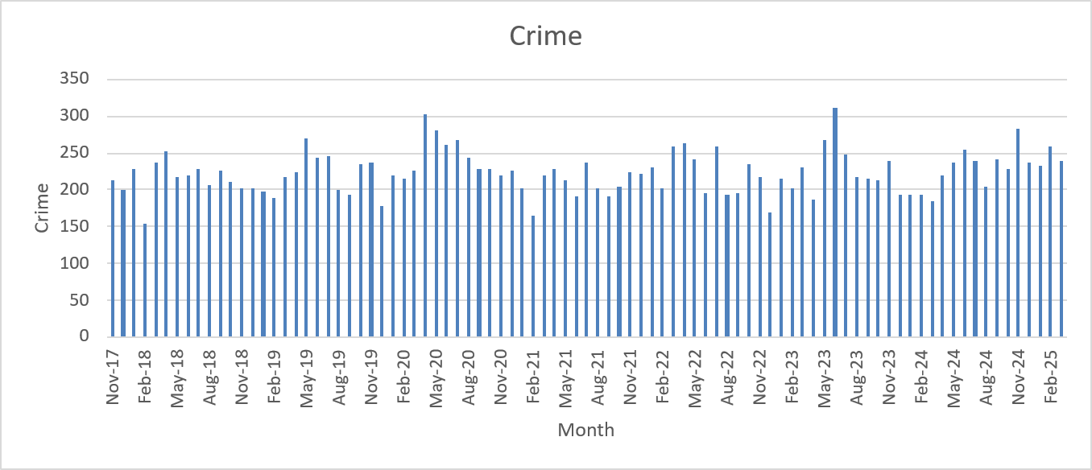

The column chart displays the number of crimes recorded each month in Beckton from November 2017 to August 2025. Monthly crime levels typically fall between 150 and 300 incidents, with natural month-to-month variation. Although the values rise and fall throughout the series, there is no clear long-term upward or downward trend, indicating that overall crime levels in Beckton have remained broadly stable over the eight-year period.
A noticeable seasonal pattern is present. In many years, crime levels rise slightly during the spring and summer months and fall again during the winter. This aligns with well-known patterns in criminology: warmer weather leads to more outdoor activity, social gatherings, and public interactions, which can increase opportunities for crime. Conversely, colder and darker months tend to reduce movement and social events, contributing to lower crime counts.
Several months stand out as short-term spikes, such as April 2020, May 2023, and October 2024. These sharp increases may be linked to specific local circumstances, changes in reporting, policing adjustments, or unusual events. The spike in early 2020, for instance, may relate to the onset of the COVID-19 pandemic, a period marked by sudden shifts in behaviour and law-enforcement priorities.
Chart details:
- X-axis: Monthly timeline (Nov 2017–Aug 2025)
- Y-axis: Number of recorded crimes
- Bars: Monthly crime totals
- Overall range: Approximately 150–320 crimes per month

Task 3: -

X-axis (horizontal): Crime count intervals (bins of size 20)
Y-axis (vertical): Number of months that fall into each crime interval
The histogram provides a clear picture of how monthly crime counts in Beckton were distributed across the 92-month period. Each bar represents a band of crime numbers, and its height reflects how many months recorded values within that band.
Most of the observations fall between 200 and 260 crimes per month, indicating that this range represents the “typical” level for Beckton. The interval 220–240 appears most frequently, occurring in well over 25 months, which highlights that crime levels were often centred around this mid-range.
Only a few months recorded unusually low or unusually high crime levels. Crime totals below 180 or above 300 were uncommon, showing that substantial dips or spikes happened infrequently.
Overall, the distribution resembles a roughly bell-shaped pattern, although not perfectly symmetrical. This suggests that Beckton’s monthly crime figures tend to cluster around a stable central value, with only occasional deviations toward the lower or higher ends.

Task 4: -

The percentage-change chart shows how crime levels in Beckton shifted each month compared with the same month in the previous year. Instead of focusing on the actual number of crimes, this graph highlights whether crime rose or fell over time. The line moves both above and below zero, which shows that crime did not follow a single upward or downward trend. Instead, there were repeated periods of increases followed by declines.
For most of 2018–2019, the month-to-month differences stayed within about –10% to +30%, suggesting that year-on-year changes were generally moderate. Small clusters of positive growth were often followed by months where the percentage fell below zero, indicating that short-term rises were usually balanced by later reductions.
The most striking feature of the graph is the sharp decline during 2020, where many months drop between –20% and –35%. This period aligns with COVID-19 lockdowns, when restrictions on movement and social interaction likely reduced opportunities for crime. As restrictions eased, crime levels gradually moved back into positive territory during 2021, reflecting a return to more typical social activity.
Throughout 2022 and 2023, the graph shows renewed volatility, including occasional large spikes (one above +60%). These abrupt changes may reflect isolated local incidents, adjustments in reporting practices, or short-term disturbances as communities recovered from pandemic disruptions.
By 2024 and early 2025, the percentage changes become much smaller and hover close to zero. This suggests that crime levels were stabilising, with monthly figures becoming more consistent compared with the previous year.

.

Task 5
The indexed chart tracks how recorded crime, nominal police spending, and inflation-adjusted police spending have changed in England and Wales from 2008/09 to 2023/24, using 2007/08 as the base year (index = 100). The three lines show that crime levels and policing costs followed very different long-term patterns.
The crime index (blue line) trends steadily downward across the period, reaching roughly 82 by 2023/24. This indicates that recorded crime fell by around 18% compared with the base year, even though there are some short-term rises and dips along the way. Overall, it suggests a gradual long-term reduction in crime.
The pattern for police spending contrasts sharply. The nominal policing cost index (red line) remains above 100 for most of the timeline and climbs to around 140–145 in the mid-2010s. This means that, without adjusting for inflation, police budgets appear to have increased by about 40% since the base year.
However, once inflation is taken into account, the picture looks very different. The real policing cost index (green line) initially rises slightly but then declines steadily, reaching about 87 by 2023/24. This shows that, in real terms, police budgets have lost around 13% of their purchasing power since 2007/08.
The widening gap between the nominal and real cost indices clearly illustrates how inflation has gradually reduced the effective value of police funding, even though the headline (nominal) figures suggest an increase.

Task 6
The chart compares how total crime, nominal policing costs, real policing costs (adjusted to 2023/24 prices), and crime per thousand people have changed between 2008/09 and 2023/24, using 2007/08 as the base year (Index = 100).
By including crime per thousand population, the chart provides a more balanced long-term picture because it accounts for population growth over the same period.
Across these 16 years, crime in England and Wales shows a clear downward trend. The overall crime index declines to around 82, meaning recorded crime is about 18% lower than in the base year. When crime is adjusted for population size, the drop becomes even more pronounced: the crime per thousand population index falls to approximately 75–78, representing a 22–25% reduction in the likelihood of experiencing crime at the individual level.
In simple terms, despite the national population increasing by several million people, the average person today faces a lower risk of being a victim of crime compared with the late 2000s.
In contrast to the fall in crime, the nominal policing cost index rises steadily, reaching about 140–145, which suggests police spending in cash terms increased by roughly 40%. However, once inflation is considered using the GDP deflator, the real policing cost index settles at around 87. This indicates that the true purchasing power of police budgets has actually fallen by about 13% since 2007/08.
This means that although headline spending numbers appear higher, much of that increase is explained by inflation rather than a substantial rise in the real resources available to policing.

Task 7: -

The indexed chart showing crime per thousand residents across England and Wales from 2007/08 to 2023/24 highlights a strong national pattern: crime rates per person have generally fallen across all regions, with only a small rise in the most recent years. Because the index uses 2007/08 as the base year (Index = 100), it allows us to compare long-term trends fairly by removing the influence of population growth.
From 2008/09 through to around 2020/21, every region shows a steady decline in crime per thousand people, typically amounting to a 20–30% reduction compared with the base year. This indicates a meaningful improvement in personal safety and a decreasing likelihood of victimisation across most of the country.
Regions such as the East Midlands, East of England, and South West show the sharpest declines, which may reflect effective regional policing strategies and manageable demographic pressures.
In contrast, London and the West Midlands remain consistently above the national average and decline at a slower pace. These areas face the challenges typical of major urban centres—higher population density, greater inequality, and more movement of people—which can make reductions in crime more difficult to achieve.
A notable drop appears around 2020–2021, coinciding with the COVID-19 lockdowns. Restrictions on movement significantly reduced opportunities for criminal activity, causing crime levels to fall across all regions. Once restrictions eased, crime per thousand residents began to rise slightly again during 2022–2023.
Despite this small rebound, every region ends the period well below the 2007/08 crime index, confirming that, over the long term, the risk of crime per person has decreased substantially across England and Wales.

Session 3

Task 1: -
Objective:
To design the database structure for the soil survey dataset, defining the data types and identifying primary keys.

Table | Field | Data Type | Description | Key
SOIL_ID | soil_id | INTEGER | Unique soil record ID | Primary Key
 | soil_type | INTEGER | References soil type | Foreign Key → SOIL_TYPE(soil_type)
 | ph_val | REAL | Soil pH value
 | sur_id | INTEGER | References surveyor | Foreign Key → SURVEYOR(sur_id)
 | assessed | NUMERIC | Date of assessment (YYYY-MM-DD)
SOIL_TYPE | soil_type | INTEGER | Unique soil type code | Primary Key
 | soil_name | TEXT | Soil type name
 | series | INTEGER | Soil series number
SURVEYOR | sur_id | INTEGER | Unique surveyor ID | Primary Key
 | surveyor | TEXT | Surveyor’s name
 | company_id | INTEGER | Company identifier

Relationships
- SOIL_ID.soil_type → SOIL_TYPE.soil_type
- SOIL_ID.sur_id → SURVEYOR.sur_id

Entity Relationship:
SOIL_TYPE (1) ───< SOIL_ID >─── (1) SURVEYOR

Task 2:

Objective:
To create the database and define the tables in SQLite.
Process:
- Opened SQLite Browser / Spatialized GUI
- Created a new database named SoilSurvey.db
- Defined tables using the Create Table tool and confirmed primary keys
- Checked structure via PRAGMA table_info()

Task 3

Objective:
To load the soil data from the provided tables into SQLite using CSV files.
Process:
- Copied table data from the PDF to Notepad
- Replaced spaces with commas using the Replace tool
- Saved files as:
  - SOIL_ID.csv
  - SOIL_TYPE.csv
  - SURVEYOR.csv
- Imported each file using
File → Import → Table from CSV file
and ticked “Column names in first line”
- Verified successful import under Browse Data

Task 4: -

SQL Query:
SELECT
soil_id,
soil_type,
ph_val,
sur_id,
assessed
FROM SOIL_ID
WHERE ph_val > 5
ORDER BY ph_val;

OUTPUT TABLE: -

soil_id | soil_type | ph_val | sur_id | assessed
213 | 32 | 5.12 | 1 | 1991-12-24
222 | 26 | 5.13 | 3 | 1990-05-19
225 | 17 | 5.34 | 4 | 1992-07-04
141 | 17 | 5.43 | 3 | 1990-11-22
212 | 27 | 5.44 | 3 | 1992-07-04
245 | 21 | 5.74 | 4 | 1990-11-06
193 | 17 | 6.44 | 4 | 1990-05-19
179 | 17 | 6.54 | 1 | 1992-09-17
170 | 30 | 6.54 | 4 | 1989-09-12

Rows are displayed in ascending order of pH value, showing only those with ph_val > 5.

Task 5:
Query: -

SELECT
SOIL_ID.soil_id,
SOIL_ID.ph_val,
SOIL_ID.assessed
FROM SOIL_ID
JOIN SURVEYOR ON SOIL_ID.sur_id = SURVEYOR.sur_id
WHERE
SURVEYOR.surveyor = 'N.Brown'
ORDER BY
SOIL_ID.assessed DESC;

OUTPUT: -

soil_id | ph_val | assessed
261 | 3.29 | 1992-07-04
182 | 3.34 | 1991-12-24
254 | 4.32 | 1991-12-24
194 | 4.52 | 1990-11-06
216 | 4.73 | 1990-11-06
232 | 4.32 | 1990-05-19
274 | 4.56 | 1990-05-19
157 | 2.36 | 1989-07-12

Interpretation of output: -

- The query joins the SOIL_ID and SURVEYOR tables to locate all soil samples collected by the surveyor N. Brown. The JOIN clause establishes relationships using the surveyor ID (sur_id) field found in both tables; thus, only samples attributed to N. Brown will be displayed.
- The WHERE clause selects records matching the query while the ORDER BY SOIL_ID.assessed DESC statement orders the output from the most recent assessment, showing the most recent samples first.
- The output reveals eight soil samples assessed between 12 July 1989 and 4 July 1992, with pH values ranging from 2.36 to 4.73.
- All of these values are below 5, indicating that the soils collected by N. Brown were moderately to strongly acidic.
- The most recent assessments, such as soil IDs 261 (pH 3.29) and 254 (pH 4.32), suggest consistently acidic conditions across different years and locations.
- The chronological sequence intends to highlight that N. Brown's survey work had been extending for several years and illustrates a clear temporal account of soil acidity trends.

Task 6:

Query: -
SELECT
SOIL_ID.ph_val,
SOIL_TYPE.soil_name
FROM SOIL_ID
JOIN SOIL_TYPE
ON SOIL_ID.soil_type = SOIL_TYPE.soil_type
WHERE
SOIL_TYPE.series = 3
ORDER BY
SOIL_TYPE.soil_name ASC;

OUTPUT: -
ph_val | soil_name
2.9 | Clay
3.43 | Clay
3.44 | Clay
4.52 | Clay
4.65 | Clay
2.36 | Gravel
3.54 | Gravel
4.56 | Gravel
6.54 | Gravel
2.22 | Sand
3.33 | Sand

The following query connects the SOIL_ID and SOIL_TYPE tables using their shared field soil_type. Then it filters the results to include only soils in series 3, which includes types of soil: Clay, Glacial Sand, Gravel, River Alluvium and Sand. The results are sorted alphabetically according to the name of soil available which has helped in comparison of pH values within various soil types in the same series. From this data point of view, the results show pH ranges in the sampled soils in series 3 range from 2.22 (strongly acidic) to 6.54 (close to neutral) which indicates that there is a wide range of soil acidity even in a single soil series.

Reflection

This real-world exercise allowed me to learn the fundamentals of using relational databases through the platform SQLite, which is an excellent choice for organizing and analysing research data. Having set up and connected the SOIL_ID, SOIL_TYPE, and SURVEYOR tables helped me better understand how these data relationships, keys, and normalization all work something that is essential to keeping research data accurate and reliable. By writing SQL queries I could read out specific information, like soil samples in specific pH ranges or results associated with certain surveyors.
It is precisely the kind of task I may have to undertake in my own research as management and/or interpretation of environmental or spatial datasets can frequently be a critical step. On the whole, this task has helped my skills in designing structured databases, constructing queries and interpreting the results in table-form. These are valuable skills both for my academic work and for any future role that involves data-driven research.

Session 4: -

Task1
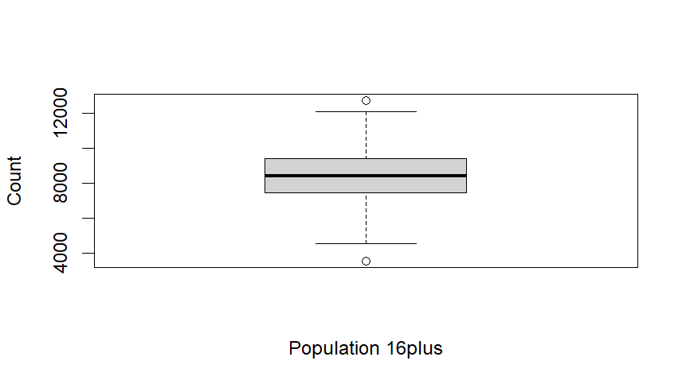

Interpret:
The boxplot gives a visual summary of how the population aged 16 and over is distributed across the London areas. The bold horizontal line inside the box marks the median, showing that the typical area has roughly 8,000 to 9,000 residents aged 16+.
The box itself represents the middle half of all values (the interquartile range), which shows that these populations vary moderately from one area to another. The whiskers extend outward to show the wider spread of the data, with most areas falling between about 5,000 and 12,000 people.
There are also a couple of outliers — one noticeably lower than 4,000 and another above 12,000 — meaning that a few areas have significantly fewer or significantly more adults aged 16+ than the general pattern seen across London.

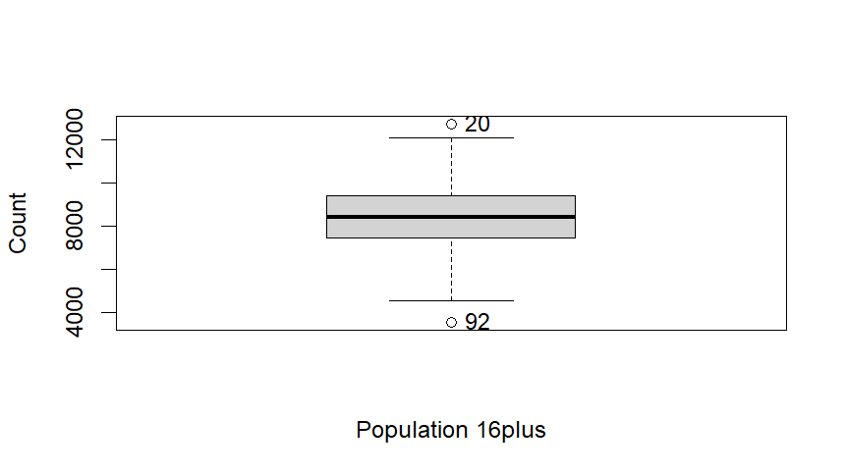
In this dataset, two locations clearly appear as outliers: Burnt Oak in Barnet (row 20) with a population of 3,235, and Crystal Palace in Bromley (row 92) with a population of 1,834. These figures are much lower than the typical 16+ population seen across most London areas.
Because they fall well below the general range, these areas may require different planning considerations—for example, in terms of service provision, resource allocation, or community needs—compared with the majority of areas that have much larger adult populations.
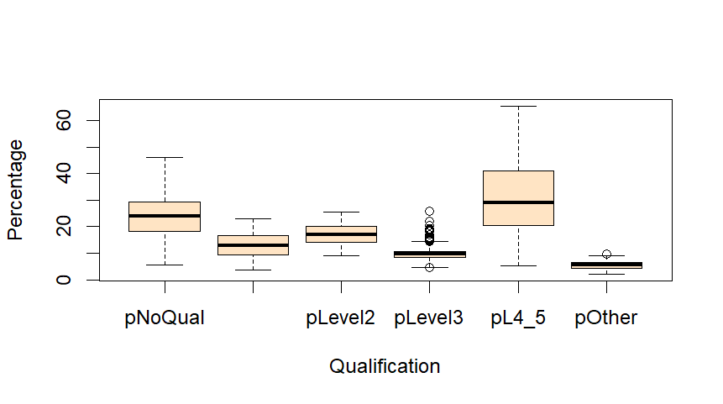
Interpretation of the Boxplot
The boxplot shows how different qualification levels are distributed across London’s neighbourhoods, based on the percentage of residents who hold each type of qualification. The results highlight strong differences between qualification categories.
The Level 4/5 qualification group (degree-level or higher) has both the highest median percentage and the widest spread. This means many areas have a large proportion of highly educated residents, but the levels vary a lot across London. Some neighbourhoods have a very high share of university-educated people, while others have much fewer.
The No Qualification group also shows a wide range. This indicates that educational disadvantage is not evenly spread; some areas have very small numbers of residents with no qualifications, while others have much higher proportions.
The middle categories—Level 2, Level 3, and Other Qualifications—have lower median values and much tighter spreads. This suggests these qualification levels are less common overall and more consistent from area to area. Level 3 includes a few outliers, meaning a small number of neighbourhoods have unusually high percentages compared with the rest.
Overall, the boxplot reveals clear educational inequalities across London, with large differences in both high- and low-qualification groups depending on the area.

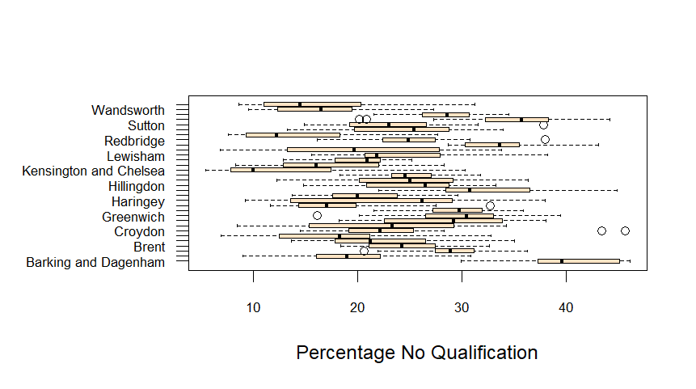

Some boroughs—such as Wandsworth, Sutton, and Redbridge—show lower median values, generally in the mid-teens. This means that these areas have a relatively small proportion of residents with no formal qualifications.
In contrast, Barking and Dagenham has a noticeably higher median and a much wider spread. In some neighbourhoods within this borough, the percentage of residents without qualifications rises above 40%, indicating more significant educational disadvantage.
Other boroughs, including Lewisham, Haringey, Greenwich, and Croydon, fall in the middle range, with median values around 20–25%. These boroughs show moderate levels of educational attainment, with some variation between different neighbourhoods.

Task 2
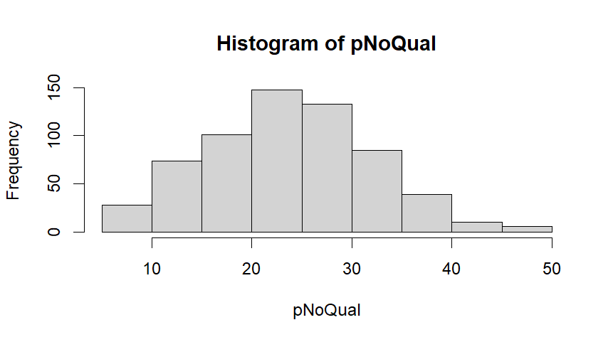
Interpretation
Rank | Borough | Ward | pNoQual
1 | Westminster | St James’s | 5.43%
2 | Camden | Frognal and Fitzjohns | 7.86%
3 | Camden | Belsize | 10.70%
4 | Kensington and Chelsea | Courtfield | 10.78%
5 | Richmond upon Thames | Kew | 10.83%

The histogram shows how the percentage of adults aged 16 and over with no qualifications (pNoQual) is distributed across 624 London wards, using intervals of 10 percentage points. Most wards fall within the 20–30% range, which contains 281 wards—almost half of the total. This tells us that in many London neighbourhoods, roughly one in four adults has no formal qualifications, making this the most common pattern across the city.
The lower end of the distribution is small: only 28 wards have fewer than 10% of residents without qualifications, and these are mainly found in more advantaged central or inner-London areas. The higher end is more spread out, with 16 wards showing more than 40% of adults without qualifications—typically located in more deprived outer boroughs.
Overall, the distribution resembles a broad bell shape centred around 24%, suggesting that limited qualifications are a common issue across London. However, the presence of both very low and very high values shows clear educational inequality. Most wards may benefit from general adult-learning support, while a smaller number of highly deprived areas may require more targeted, intensive educational interventions.

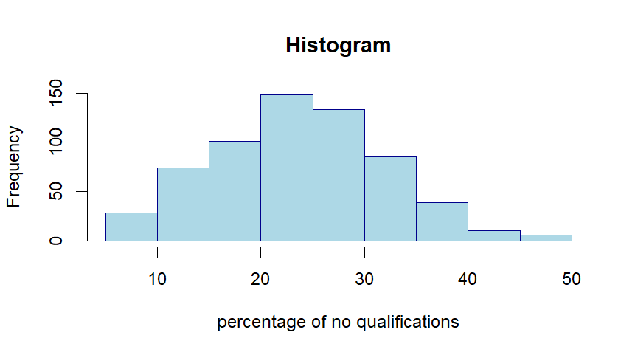
The histogram shows how the percentage of adults aged 16 and over with no qualifications is spread across 624 London wards, using 10-point percentage intervals. The distribution has a single peak and is slightly skewed to the right. The largest concentration of wards falls in the 20–30% range, with around 280 wards (about 45%). This means that in many London neighbourhoods, having roughly one in four adults without qualifications is the most common pattern.
Only a small number of wards fall below 15%, which indicates that very low levels of educational disadvantage are relatively rare. On the other hand, although the frequency drops after the 30% bin, the right tail stretches toward nearly 50%. About 16 wards (around 2.6%) have more than 40% of adults with no qualifications—highlighting a small cluster of areas with serious educational disadvantage.
Overall, the pattern shows a moderate but widespread skills gap, centred around 24%. However, the uneven spread reveals that while most wards would benefit from general adult-education support, a smaller group of highly deprived wards requires more intensive, targeted intervention.

Task 3
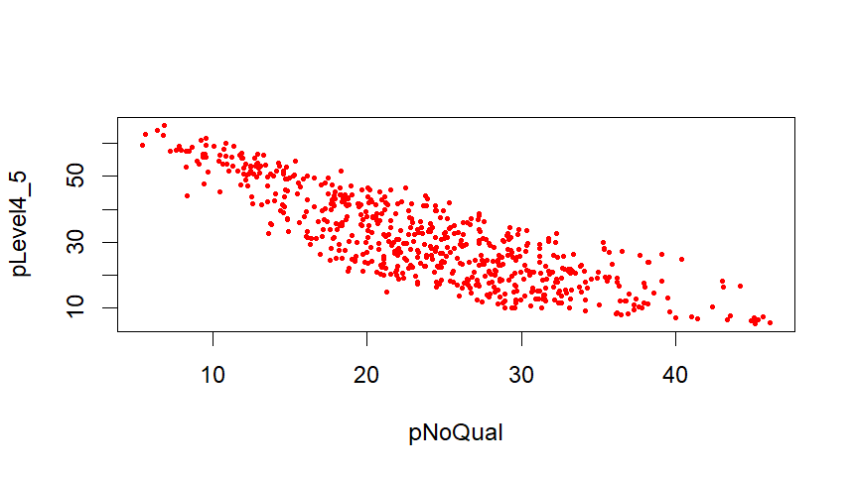
Interpretation
The scatter plot shows how the percentage of adults with no qualifications (pNoQual) relates to the percentage of adults with the highest qualifications (pLevel4_5) across 624 London wards. The pattern is strongly negative: as the share of residents with no qualifications increases, the proportion of highly qualified adults falls sharply.
Wards with low pNoQual (around 5–10%) tend to have very high levels of university-educated residents—often above 60%. These wards, shown at the top-left of the plot, typically represent more affluent and central parts of London. In contrast, wards with high pNoQual (30–45%) nearly always have very low percentages of highly qualified adults, usually below 10%. These appear on the bottom-right of the plot and reflect more disadvantaged outer-London areas.
The points form a clear downward-sloping band, showing that these two educational measures move in opposite directions and rarely overlap. In other words, areas with strong educational disadvantage almost never have a high concentration of graduates.
Overall, the plot highlights a clear educational divide across London. It shows that pNoQual is a strong indicator of overall educational attainment within a ward and closely linked to how many residents hold degree-level qualifications.

Task4
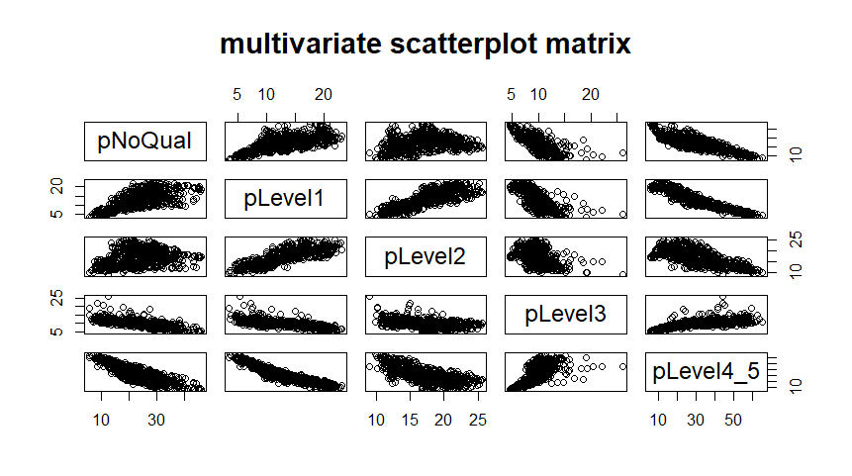

The multivariate scatterplot matrix shows how the percentage of adults with no qualifications (pNoQual) relates to the percentages of adults holding different qualification levels (pLevel1 through pLevel4_5) across 624 London wards. Each scatterplot compares two variables, and across all panels a consistent pattern appears: as pNoQual increases, the percentages of residents with higher qualification levels decrease. This is most visible with pLevel4_5 (degree-level and above), where wards with high pNoQual have almost no graduates, while wards with very low pNoQual often have over 60% highly qualified adults. The middle qualification levels (Level 1, 2, and 3) show the same downward trend, though less sharply. The diagonal plots summarise the spread of each variable, showing that pNoQual is most common around 20–30%, while pLevel4_5 is split between wards with very low and very high levels of higher education. Overall, the matrix highlights a strong educational divide across London: areas with many residents lacking qualifications consistently have fewer people at all higher qualification levels, making pNoQual a key indicator of overall educational attainment in a ward.

Task 5

Section4: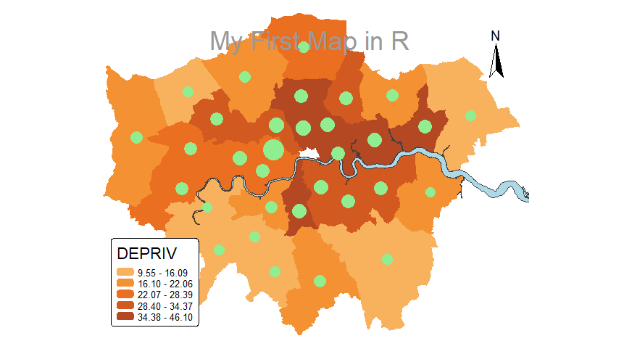
I produced a layered map of London using tmap, bringing together several types of spatial information in one visual. The boroughs were shaded using a five-class quantile scale to show levels of deprivation, with darker orange indicating more deprived areas. I added the River Thames in light blue to provide geographic context, and placed proportional light-green circles on each borough to represent both the total number of burglaries and the crime rate per 1,000 residents. Each variable was scaled separately so that crime volume and crime intensity could be compared fairly. By adjusting layer order, classification method, symbol sizes, transparency, the legend and other layout settings, the final map clearly showed that higher deprivation is often associated with higher crime rates—particularly in parts of outer east London. Central areas, meanwhile, tended to show high burglary totals even where deprivation levels were only moderate. This exercise helped me understand how to combine multiple spatial datasets, manage visual hierarchy, and use mapping techniques to communicate complex social patterns in a clear, professional way.

Session 5

Task 1:

If Jack and Jill have ten children, and each child has an equal 50% chance of being a boy, we can use the binomial distribution to work out the probability of having exactly seven boys. Using the formula—or the Excel function BINOM.DIST(7, 10, 0.5, FALSE)—the probability is about 11.7%. This shows that getting seven boys is possible but not very common. The most likely outcome is five boys, because when the chance of a boy is 50%, the binomial distribution is perfectly balanced. As a result, five boys has the highest number of possible combinations, making it the most frequent result in the long run.

Task2:

If tsunamis occur on average once every three years, we can use the Poisson distribution to estimate how likely it is to see exactly one tsunami in any given year. With an average rate of λ = 1/3 per year, the probability of having one tsunami comes out to about 24% when calculated using the Excel function POISSON.DIST(1, 1/3, FALSE). This tells us that most years will have no tsunami at all, but there is still a meaningful chance that one could happen. While one tsunami per year is not the most common outcome, the probability is high enough that it should be taken seriously for risk assessment and planning.

Task3

If Professor Brimicombe’s height is measured repeatedly, with an average of 162.4 cm and a standard deviation of 0.94 cm, a normal distribution is a suitable way to describe how his measurements vary.
- Chart 1 (Cumulative = FALSE):
This chart shows the probability of recording a specific height value. For continuous measurements, the chance of getting one exact number—like exactly 164 cm—is extremely small. Excel calculates this using NORM.DIST(164, 162.4, 0.94, FALSE).
- Chart 2 (Cumulative = TRUE):
This chart shows the probability that his measured height is less than or equal to 164 cm. Using NORM.DIST(164, 162.4, 0.94, TRUE) gives a result of about 96%, meaning only about 4% of measurements would be above 164 cm. Column K records this “greater than” probability.
Overall, the two charts work together to show that most height measurements fall below 164 cm, and only a small number of measurements will exceed it. They illustrate both the likelihood of a single height value and the cumulative probability of being below or above that point.

Session 6

Task1:
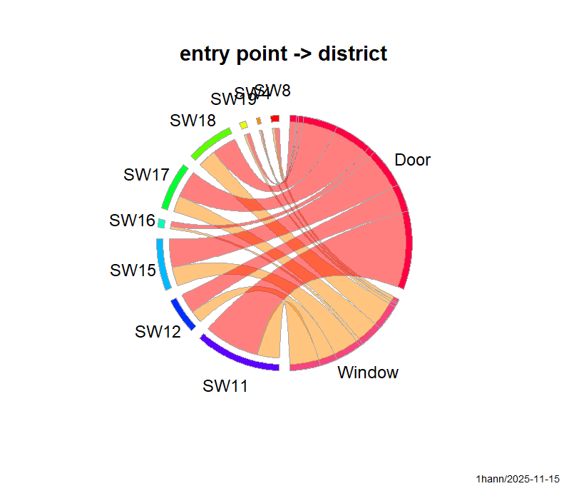

The circular chart showing the relationship between entry point and district makes it clear that most burglaries across all areas happen through doors, but the balance between door and window entries differs from one district to another. The thickest ribbon connects Door → SW11, meaning SW11 has the highest count of burglaries involving doors and relies on this entry method more than other districts. Meanwhile, districts such as SW18, SW15, and SW4 show relatively stronger links to window entries, indicating that burglars use windows more often in these places compared with others. This visual pattern supports the chi-square test, which found that the distribution of door versus window entries is not the same across districts.
2.1 District × Entry Point (Door vs Window)
- H₀: District and entry point are independent (no relationship).
- Chi-square result: χ²(8) = 54.193, p = 6.33 × 10⁻⁹; Cramer’s V = 0.118.
- Decision: Reject H₀, because p < 0.05.
- Interpretation: There is a statistically significant—though small—association between district and method of entry. For example, SW11 has more door entries than expected, while SW18, SW15, and SW4 show higher-than-expected window entries.

Task2:
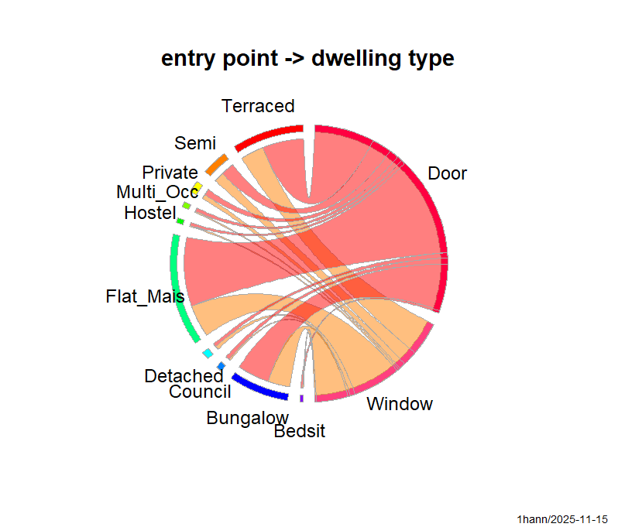
The circular plot showing entry point and dwelling type highlights clear behavioral differences depending on the kind of property. Flats and marionette’s have a very strong connection to door entries, meaning burglars almost always enter these buildings through doors—likely because shared entrances and upper-floor positions make windows harder to access. In contrast, bungalows, detached houses, and semi-detached houses display much thicker ribbons from windows, suggesting that burglars frequently use windows in these types of homes, possibly due to easier ground-floor access. Terraced houses fall somewhere in between, with noticeable use of both doors and windows. These visual patterns align with the chi-square results, which show that dwelling type and entry method are significantly related. In simple terms, burglars choose their entry route based on the structure of the property.

New requirement: Door vs Window by day of the week
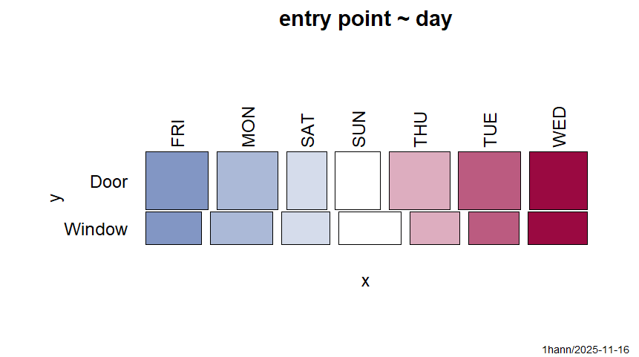
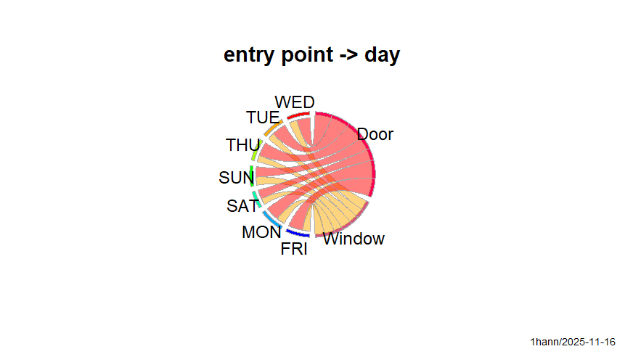
The new circular plot that compares entry point with day of the week reveals how burglary entry behavior varies over the weekly cycle. Door entries dominate across all days, but the proportions shift slightly depending on the day. Weekdays, especially Tuesday, Wednesday, and Thursday, show a higher proportion of door entries, suggesting burglars often take advantage of predictable routines—such as people leaving for work. On the other hand, weekends (especially Saturday) show relatively stronger connections to window entries, possibly because homes are more occupied and burglars may look for quieter, less visible points of access. The chi-square test confirms that the distribution of door versus window entries is not the same throughout the week, meaning entry method and day of the week are statistically linked. Overall, the patterns suggest burglars adapt their entry strategy based on daily activity levels and occupancy
The Pearson Chi-square test shows that the day of the week is meaningfully related to the entry method used in burglaries. The test results were:
- χ²(6) = 30.957
- p = 2.583 × 10⁻⁵
- Cramer’s V = 0.089
Because the p-value is well below 0.05, we reject the null hypothesis of independence. This means that the pattern of door versus window entries changes across the week. Although the effect size is small (as shown by Cramer’s V), the association is statistically significant, indicating that burglars do not use entry methods uniformly across different days.

Dwelling Type × Entry Point
- H₀: Dwelling type and entry method are independent.
- Result: χ²(9) = 36.866, p = 2.78 × 10⁻⁵; Cramer’s V = 0.098.
- Decision: Reject H₀.
- Interpretation: The method burglars use to enter a property varies significantly by dwelling type, although the effect size is small. Flats and maisonettes experience more door entries than expected, whereas bungalows, detached, and semi-detached homes show relatively fewer door entries and greater use of windows.

Male vs Female Counts (Paired Wilcoxon Test)
- H₀: The median difference between male and female counts = 0.
- Result: V = 81.5, p = 0.0003899, r ≈ 0.62.
- Decision: Reject H₀.
- Interpretation: Based on raw attendance counts, female attendance is significantly higher than male attendance across boroughs. The effect size is large (r ≈ 0.62).

Inner vs Outer Total Counts (Mann–Whitney Test)
- H₀: Inner and Outer boroughs have the same distribution of total attendances.
- Result: W = 139, p = 0.8434.
- Decision: Fail to reject H₀.
- Interpretation: There is no statistical evidence that total A&E attendances differ between Inner and Outer boroughs when using unadjusted (raw) counts.

Male vs Female Rates per 1,000 (Paired Wilcoxon Test)
- H₀: The median difference in attendance rates = 0.
- Result: V = 340, p = 0.296.
- Decision: Fail to reject H₀.
- Interpretation: After adjusting for population size, male and female A&E attendance rates do not differ significantly across boroughs.

Inner vs Outer Rates per 1,000 (Mann–Whitney Test)
- H₀: Inner and Outer boroughs have the same distribution of attendance rates.
- Result: W = 203, p = 0.00994, r ≈ 0.45.
- Decision: Reject H₀.
- Interpretation: Inner London boroughs show significantly higher A&E attendance rates per 1,000 residents than Outer boroughs. The effect is moderate in size.

3. “What difference did taking a proportion in Section 08 make?”

Using the raw A&E attendance counts, there was a clear significant difference between male and female attendances, while Inner and Outer boroughs showed no meaningful difference. However, once the data were converted into rates per 1,000 population, the pattern changed. The male–female difference was no longer significant, but a significant difference appeared between Inner and Outer boroughs. This indicates that population size was distorting the raw comparisons, and that analysing attendance rates provides a more accurate and fair reflection of how A&E use varies across boroughs with different population sizes. This directly addresses the requirement to compare results before and after adjusting for population.

Session 7

Task1:
Print the mean and quantiles for all variables to see if the mean appears to be sufficiently different from the median to indicate non-normality. Which variable(s) appear to be non-normal?
Output
Variable | Mean | Median | Interpretation
rent | 35.94 | 32.50 | close → approx. normal
unemp | 11.58 | 10.50 | close → approx. normal
lowseg | 12.44 | 12.50 | extremely close → normal
spfc | 10.70 | 10.00 | close → approx. normal
llti | 7.74 | 7.00 | noticeable difference → possibly non-normal
mobile | 9.34 | 8.00 | large difference + extreme max → non-normal

If mean ≈ median, the variable is approximately normal.
If the mean differs strongly from the median, the variable is likely non-normal.

Task2
Output
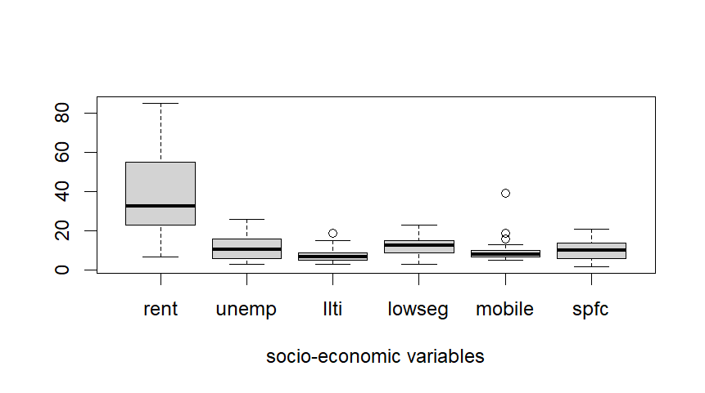
Interpretation
- rent – The spread of values is fairly even on both sides of the median, with no major outliers. This suggests rent is approximately normally distributed.
- unemp – The distribution looks balanced, and there are no unusual values at either end. unemp also appears close to normal.
- lowseg – The boxplot is centred and symmetric, with no extreme values, indicating a distribution consistent with normality.
- spfc – The shape is broadly symmetric and shows no serious outliers, so spfc can also be treated as approximately normal.
- llti – A noticeable high outlier and a longer upper whisker reveal a right-skewed distribution. llti does not follow a normal pattern.
- mobile – The data include several large outliers and a long upper tail, showing strong right-skewness. mobile is clearly non-normal.

Task 3
Create QQ plots for all variables as a further visual test of normality. Again, which variable(s) appear to be non-normal? How consistent are your thoughts across the last three visual tests?
Rent
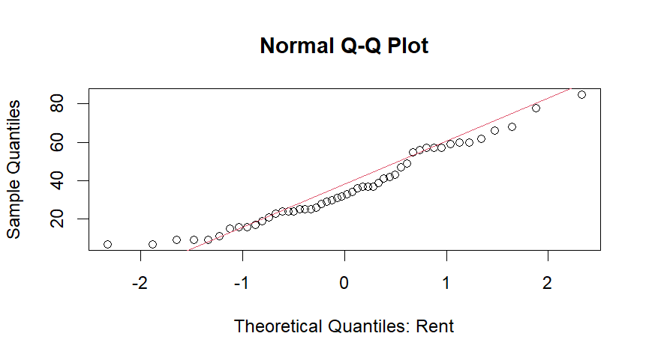
The QQ plot for rent shows that most points lie close to the diagonal reference line, indicating that the data follow the shape of a normal distribution reasonably well. There are minor departures at both the lower and upper ends, but these deviations are small and not severe. Overall, the QQ plot suggests that rent is only mildly skewed and can be considered approximately normally distributed.
Unemployment
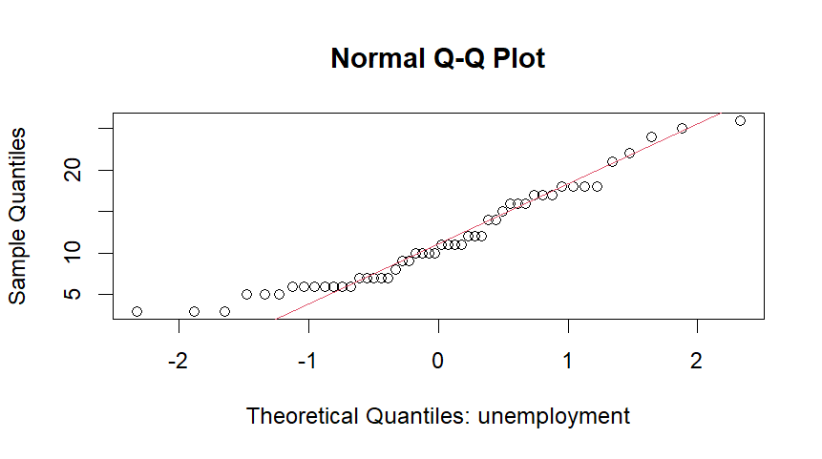
The QQ plot for unemployment shows that the points align closely with the diagonal reference line through most of the distribution. There are only slight departures at the lower and upper ends, but nothing substantial. This pattern suggests that the unemployment data are fairly symmetrical and do not display any strong skew. Overall, the QQ plot indicates that unemployment is approximately normally distributed, with only very minor deviations from normality.
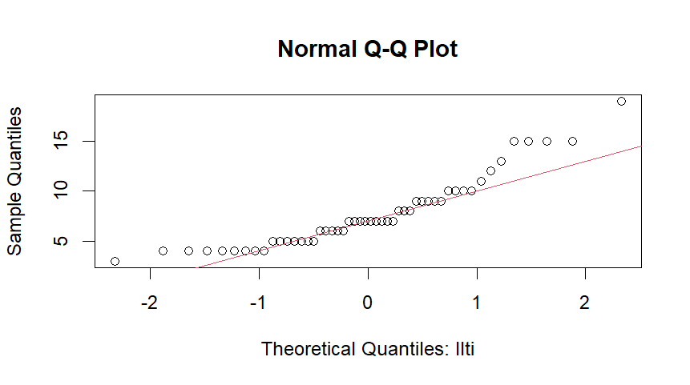
The QQ plot for llti shows noticeable departures from the diagonal line, especially at the upper end of the distribution. The points curve upward above the reference line, indicating a clear right-skew. This means that there are more high values than a normal distribution would predict. The lower end also shows some deviation, but the strongest distortion is in the upper tail. Overall, the QQ plot confirms that llti does not follow a normal distribution and has a positively skewed shape.
Lowseg
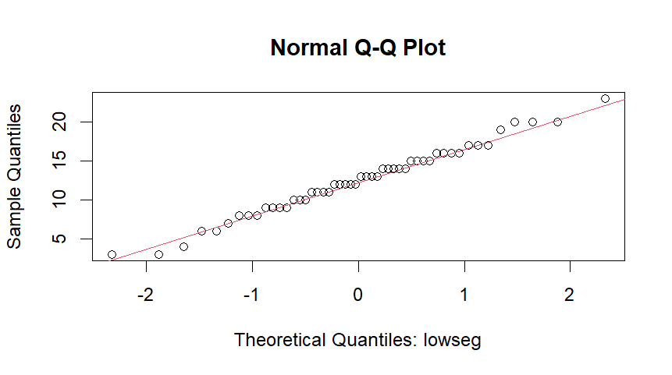
Interpretation (Lowseg – QQ Plot)
The QQ plot for lowseg shows that nearly all data points fall very close to the diagonal reference line, with only slight departures at the extreme ends. The overall pattern is straight and consistent, indicating that the distribution is balanced and does not display any meaningful skew. Taken together, the plot suggests that lowseg is approximately normally distributed, and this visual assessment aligns well with the conclusions from the earlier boxplot analysis.

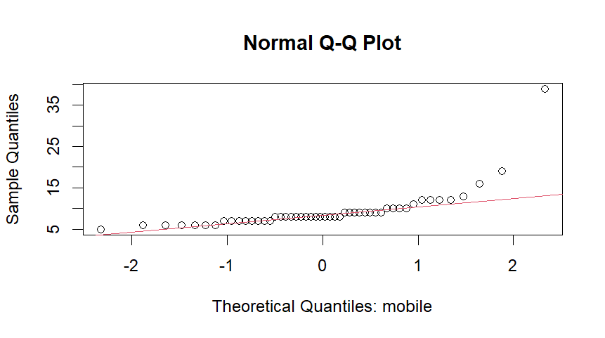

The QQ plot for mobile shows a clear departure from the diagonal reference line. Many of the points, particularly in the upper tail, rise well above the line, reflecting the presence of several unusually large values. This produces a pronounced upward curve rather than a straight pattern, indicating a long right tail in the distribution. Overall, the QQ plot demonstrates that mobile is not normally distributed and is strongly right-skewed, which is consistent with the evidence from the boxplot and the Shapiro–Wilk test.

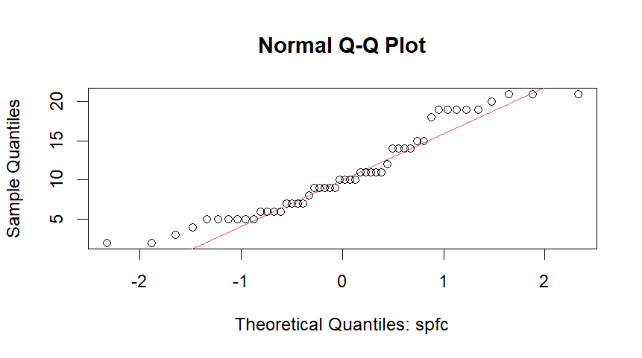
The QQ plot for spfc shows that the points align closely with the diagonal reference line across most of the distribution. While there are slight departures at the lower and upper ends, these deviations are small and do not indicate any major skewness or heavy tails. The overall straight pattern suggests that the data is fairly well balanced.
In summary, spfc appears to be approximately normally distributed, with only minor tail deviations that do not meaningfully violate normalit

Task4

Variable | KS p-value | Interpretation
rent | 0.7178 | fail to reject H₀ – consistent with normality
unemp | 0.3138 | fail to reject H₀ – consistent with normality
llti | 0.07345 | p just above 0.05 – borderline but do not reject H₀
lowseg | 0.9928 | fail to reject H₀ – very close to normal
mobile | 0.001572 | p < 0.05 – reject H₀
spfc | 0.2937 | fail to reject H₀ – consistent with normality

Conclusion: these four variables are approximately normally distributed and do not show strong departures from normality.
Task 5:

1) rent vs lowseg

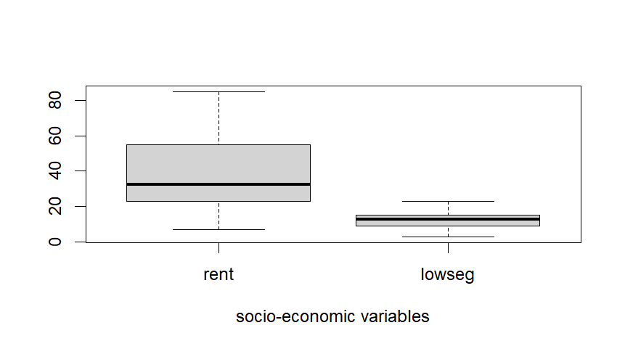
Before running the t-test, I first checked how spread out the two variables were. Rent had a much larger variance than lowseg, so I used the t-test that does not assume equal variances (Welch’s t-test).
The test produced a very small p-value (p < 0.001). This means the difference between the average values of rent and lowseg is not due to chance.

Rent values are clearly higher than lowseg values.
The results show that this difference is genuine and not due to random variation. The boxplot confirms this visually: rent has much higher values and shows greater spread, while lowseg is noticeably lower and more tightly grouped.
The effect size is also very large (Cohen’s d = 1.65), which means the gap between the two variables is not only statistically significant but also meaningful in practical terms.

2) unemp vs spfc

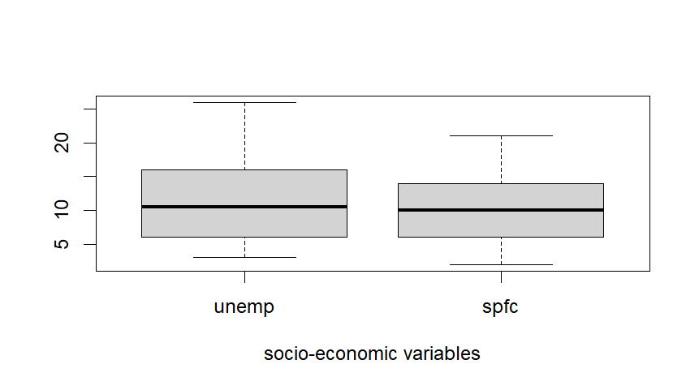
The t-test comparing unemp and spfc produced a p-value of 0.10, which is not statistically significant.
In simple terms:
- There is no strong evidence that the average unemployment percentage and the average spfc percentage are meaningfully different.
- Since the difference is not statistically significant, Cohen’s d is not reported, because effect sizes are mainly useful when a real difference exists to quantify how large it is.

Task 6:

Wilcoxon Test Interpretation (Rent vs Lowseg)
The Wilcoxon test is a non-parametric test, meaning it does not require the data to be normally distributed. Because of this, it is a good way to confirm whether the t-test result is reliable.
For rent vs lowseg, the Wilcoxon test also produced a very small p-value, leading to the same conclusion as the t-test:
- Rent values are significantly higher than lowseg values.
- Both the t-test and Wilcoxon test agree, so this strengthens our confidence that the difference is real and not due to chance.

2. Unemp vs Spfc
The Wilcoxon test produced a p-value of 0.14, which is not statistically significant.
This means:
- There is no clear evidence of a difference between unemp and spfc.
- The result matches the earlier t-test, so both tests agree that the two variables do not differ in a meaningful way.

Session 8:

Task1:
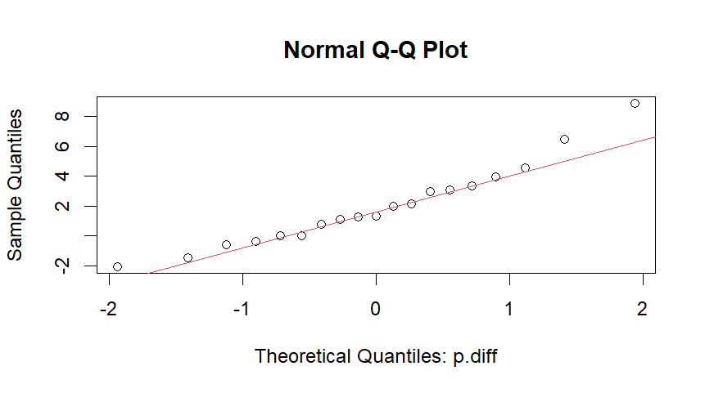
The analysis shows that freezing blood samples has a small but measurable effect on test results. The boxplot indicates that most percentage differences between the values recorded before and after freezing are close to zero, suggesting that freezing generally does not cause large changes, although a few samples show slightly bigger but still minor shifts. The Q–Q plot confirms that the data follows a roughly normal pattern, with points lying close to the diagonal line, and this is supported by the Kolmogorov–Smirnov test, which returns a very high p-value (0.9568). Because the data behaves normally, a paired t-test was used to check whether the average percentage difference was effectively zero. The t-test produced a significant result (p = 0.005), meaning the difference is unlikely to be due to chance. On average, values before freezing were about 2% higher than after freezing, showing that while the effect is small, freezing does lead to a consistent reduction in measured blood test values.

1. One-way ANOVA (F test)
Model: ed_exp ~ council
- H₀: All councils have the same mean educational expenditure
(μ_Lab = μ_Con = μ_Lib).
- Result:
F(2, 47) = 20.83, p = 3.34 × 10⁻⁷
Since p ≪ 0.05, we reject H₀.
There is strong evidence that the average amount spent on education is not the same across all councils — at least two of them differ in their mean educational expenditure.
2. Tukey HSD (pairwise comparisons)
From TukeyHSD(fit1):
- Lab – Con: diff = 18.54, 95% CI [11.59, 25.50], p_adj = 0.0000002
- Lib – Con: diff = 9.47, 95% CI [2.62, 16.32], p_adj = 0.0045357
- Lib – Lab: diff = −9.07, 95% CI [−16.03, −2.12], p_adj = 0.0077054
H₀ for each pair: The two councils have equal mean educational expenditure.
Since all the adjusted p-values are below 0.01, we reject the null hypothesis for every pair of councils.
Conclusion: all three councils differ significantly from one another in their mean educational spending, with Labour councils spending the most on average, Conservative councils the least, and Liberal councils falling in between.
3. Kruskal–Wallis test
Model: ed_exp ~ council
- H₀: The distribution (and median) of educational expenditure is the same for all councils.
- Result:
χ²(2) = 23.687, p = 7.186 × 10⁻⁶
Since p ≪ 0.05, we reject H₀.
There is strong evidence that the typical (median) level of educational expenditure differs between the councils.
This non-parametric result is in line with the ANOVA findings: both approaches show statistically significant differences in educational spending across the three councils.

Session 9

Task1:
Variables | Life_Male | Dom_Build | Smoking | Obese | Episodes | Benefits | Crime
Life_Male | 1.000 | -0.281 | -0.610 | -0.200 | -0.316 | -0.870 | -0.611
Dom_Build | -0.281 | 1.000 | 0.108 | -0.428 | -0.411 | 0.426 | 0.607
Smoking | -0.610 | 0.108 | 1.000 | 0.234 | 0.323 | 0.542 | 0.356
Obese | -0.200 | -0.428 | 0.234 | 1.000 | 0.674 | 0.123 | -0.173
Episodes | -0.316 | -0.411 | 0.323 | 0.674 | 1.000 | 0.211 | -0.137
Benefits | -0.870 | 0.426 | 0.542 | 0.123 | 0.211 | 1.000 | 0.815
Crime | -0.611 | 0.607 | 0.356 | -0.173 | -0.137 | 0.815 | 1.000

The correlation results show how different factors in London boroughs are connected to male life expectancy. The strongest relationship is with the number of people on benefits. Boroughs where more residents claim benefits tend to have much lower male life expectancy, making poverty the most important factor in this dataset. Crime also shows a strong connection, with areas that have higher crime levels generally experiencing lower life expectancy. Smoking is also linked to lower life expectancy, but when poverty is taken into account, its effect becomes weaker, suggesting that smoking is partly related to deprivation. Other factors—such as obesity, hospital episodes and the amount of domestic building land—do not show strong or clear connections to life expectancy in this dataset. Overall, the results suggest that social and economic conditions, especially poverty and crime, play the biggest role in explaining why male life expectancy differs between London boroughs.

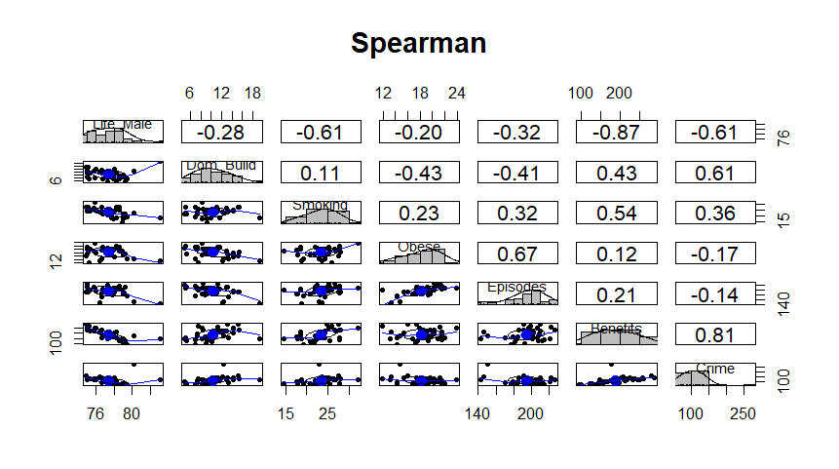

Spearman Correlation Plot – Simple Interpretation
The Spearman correlation plot shows how strongly different variables move together across London boroughs. Darker or more slanted patterns indicate stronger relationships, while flatter patterns show weaker links. The clearest pattern is between Benefits and Life Male, where boroughs with higher benefit claims almost always have lower male life expectancy — shown by the strong negative values and tight downward trend. Crime and Smoking also show noticeable downward patterns with Life Male, meaning higher crime or more smoking is associated with shorter life expectancy. Some variables, like Obesity, Episodes, and Domestic Building, show weaker or scattered patterns, suggesting little or no consistent relationship. On the other hand, there are strong positive relationships between Benefits and Crime, as well as Obesity and Episodes, meaning these pairs tend to increase together. Overall, the visual highlights that social deprivation (benefits), crime, and smoking stand out as the strongest factors connected to lower male life expectancy.

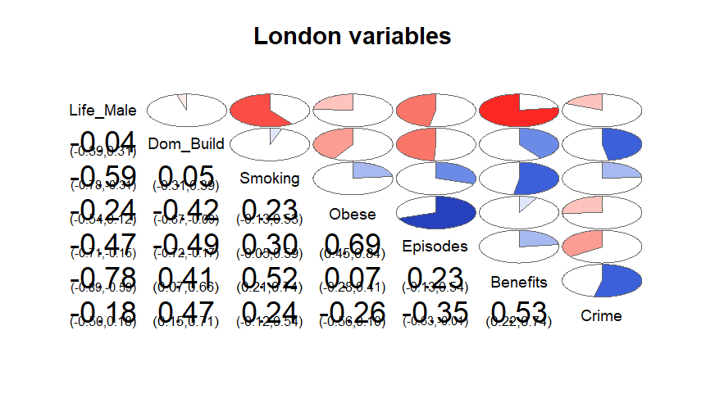
The plot shows that Benefits has the strongest negative relationship with Life_Male, meaning boroughs with high benefit claims tend to have lower male life expectancy. This is shown by the large red section between these two variables. There are also clear negative relationships between Life_Male and Crime and between Life_Male and Smoking, indicating that areas with more crime or more smoking generally see lower life expectancy. On the positive side, strong blue sections appear between Benefits and Crime, and Obese and Episodes, showing that these pairs tend to increase together across boroughs. Many other pairs show only pale colours, meaning their relationships are weak or inconsistent. Overall, the corrgram helps highlight the main drivers linked with male life expectancy, showing that social deprivation, crime, and smoking are the most important factors in this dataset.

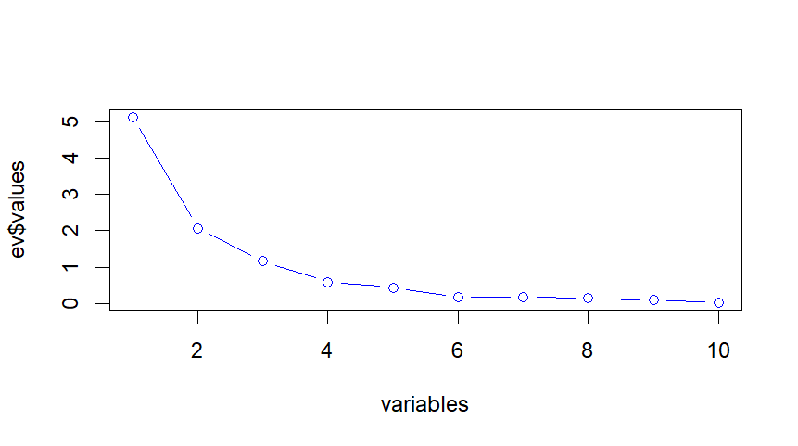
The scree plot shows how much useful information each factor contains in the data. The first factor, which reflects how built-up a borough is (more buildings and less greenspace), explains the most differences between areas. The second factor, which relates to crime levels and urban density, also explains an important part of the variation. The third factor, connected to health issues such as obesity and hospital episodes, explains a smaller but still meaningful amount. The fourth factor, mainly linked to smoking levels, also adds useful information.
After these four factors, the line on the graph becomes almost flat, which means the remaining factors do not add anything important. They contain very little information and mostly represent noise.

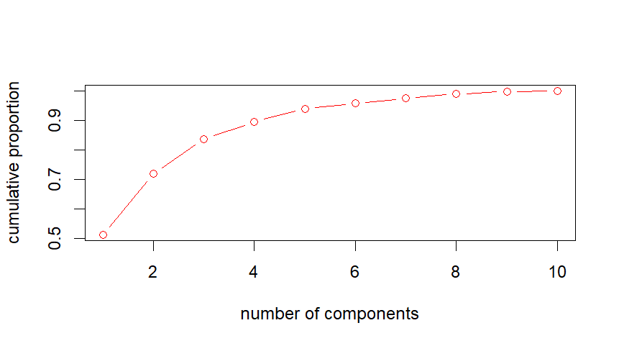
The cumulative variance plot shows how much of the dataset’s information is captured as we add more components.
From the graph, the first component explains just over 50% of the total variation. Adding the second component increases this to around 70%, and the third component raises it to about 82%. When the fourth component is included, the total explained variance reaches almost 90%.
After the fourth component, the line becomes almost flat, meaning additional components only add very small amounts of new information. These later components mostly capture minor details or noise.

Section 8: Principal Components Analysis (PCA)
Variable | RC1 | RC3 | RC2 | RC4 | h² | Notes
Dom_Build | 0.90 | 0.03 | −0.32 | −0.03 | 0.92 | Strongly built-up areas
NonDom_Build | 0.61 | 0.69 | −0.33 | 0.08 | 0.96 | Mixed built environments
Dom_Gardens | 0.07 | −0.86 | 0.31 | −0.28 | 0.92 | Garden & green land density
Greenspace | −0.90 | −0.21 | 0.15 | −0.12 | 0.90 | Green space indicator
Smoking | 0.14 | 0.16 | 0.19 | 0.91 | 0.91 | Smoking behaviours
Binge_Drink | 0.64 | 0.40 | −0.48 | 0.33 | 0.91 | Lifestyle behaviours
Obese | −0.19 | −0.20 | 0.88 | 0.05 | 0.86 | Health indicator
Episodes | −0.25 | −0.17 | 0.79 | 0.34 | 0.83 | Hospital admissions
Benefits | 0.60 | 0.42 | 0.38 | 0.40 | 0.85 | Socio-economic hardship
Crime | 0.47 | 0.82 | −0.05 | −0.02 | 0.90 | Crime & safety

Component | SS Loadings | Proportion Var | Cumulative Var
RC1 | 3.12 | 0.31 | 0.31
RC3 | 2.35 | 0.24 | 0.55
RC2 | 2.15 | 0.22 | 0.76
RC4 | 1.32 | 0.13 | 0.89

The PCA results show that four components capture 89% of all meaningful variation across the London boroughs. These represent: (1) Built environment, (2) Crime/urban intensity, (3) Health problems, and (4) Lifestyle behaviours. The model fits well (RMSR = 0.04), confirming that four components are appropriate

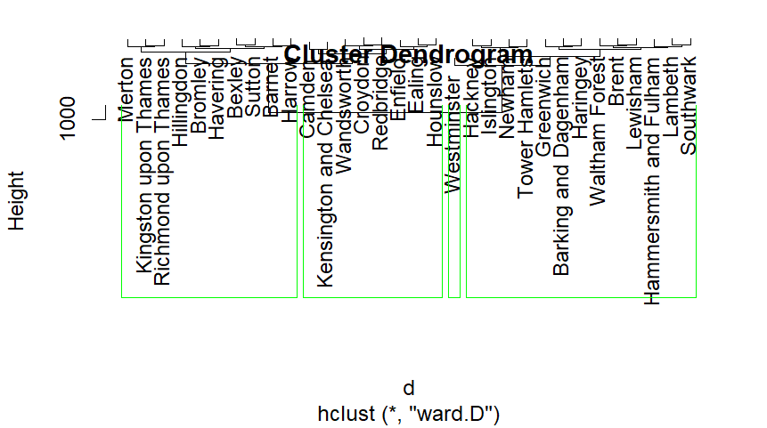
The dendrogram illustrates how the London boroughs group together based on similarities in several social and health-related factors. Ward’s method starts by looking at every borough individually and then gradually merges the most similar ones. Boroughs that sit closer together on the chart share similar characteristics (such as levels of smoking, obesity, crime, or green space).
As the diagram moves upward, groups that are less similar get merged, and the height at which they join represents how different they are. Lower joins mean very similar boroughs; higher joins mean more difference.
From this dendrogram, four main clusters clearly form. One cluster contains boroughs with healthier profiles and more green space, another shows boroughs with higher deprivation and health issues, while the others contain mixed profiles.

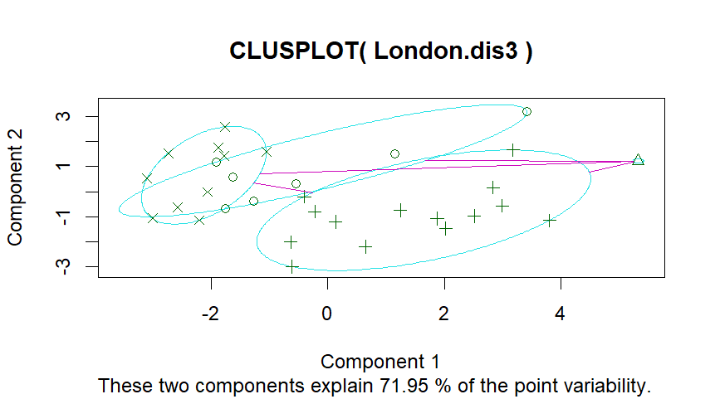

The k-means cluster plot shows how the London boroughs group together according to four key factors from the dataset: Dom_Build, Smoking, NonDom_Build, and Obese. These factors were chosen because they represented the strongest patterns in your earlier Principal Component Analysis.
In the plot, each borough is shown as a point, and the four clusters are represented by different symbols and enclosed by smooth oval shapes. The two axes (Component 1 and Component 2) do not represent single variables; instead, they combine the selected factors into two underlying dimensions that explain 71.95% of all variation in the data. This means the plot gives a reliable picture of how the boroughs differ from each other.
Boroughs positioned close together on the plot share similar social and health profiles, particularly around smoking rates, obesity levels, and types of buildings. Boroughs that sit far apart are very different in these characteristics.
Each cluster forms a distinct pattern:
- One group shows boroughs with higher smoking and obesity levels, indicating poorer health outcomes.
- Another includes boroughs with higher levels of domestic and nondomestic building, reflecting more urban infrastructure.
- A third cluster represents boroughs with mixed profiles, showing moderate values across different indicators.
- The final group contains boroughs with healthier scores, such as lower smoking and obesity.
Section 13:
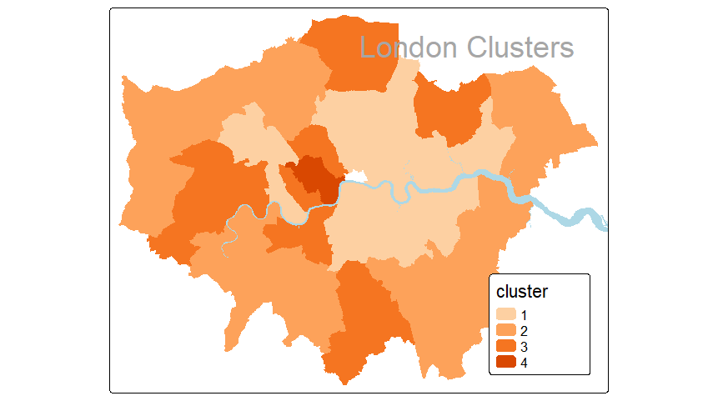

The London clusters map shows how different boroughs group together based on their social and health characteristics. Instead of looking at geography or population size, the map focuses on patterns in the data—such as smoking levels, obesity rates, crime, amount of green space, and building types. Each borough is coloured according to the cluster it belongs to, with similar colours representing areas that share similar lifestyles and environmental conditions.
The map makes it easy to see that some boroughs naturally form groups with healthier environments and more green space, while others cluster together because they experience higher levels of deprivation, health risks, or urban density. The river Thames is included to help orient the viewer, but the clusters themselves are created purely from the data, not the location.

Section 14
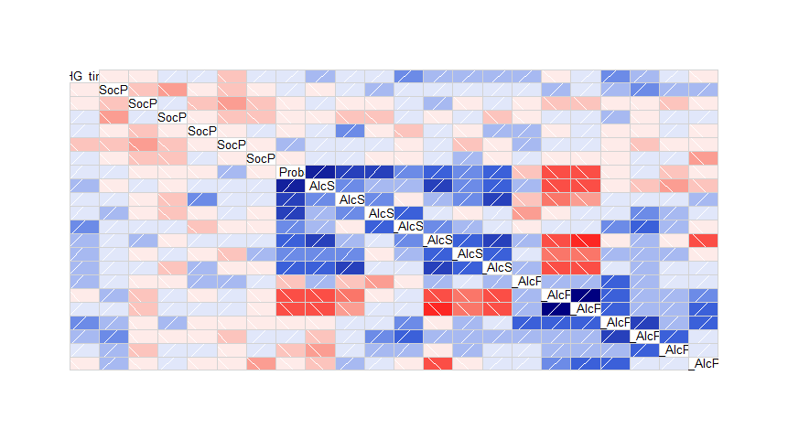
This heatmap gives a clear visual picture of how the alcohol-related measures and social-problem scores relate to one another across the London boroughs. Each coloured square represents the strength of the relationship between two variables. The colours help us interpret these relationships instantly:
- Red tones show strong positive relationships, meaning the two behaviours or issues tend to increase together.
- Blue tones show strong negative relationships, meaning one tends to rise when the other falls.
- Pale colours indicate weak or no meaningful relationship.
A noticeable pattern in the heatmap is that many of the alcohol consumption variables (labelled AlcS or AlcF) form a block of darker colours. This tells us that these alcohol measures are strongly linked—boroughs with higher alcohol scores in one area usually score higher in others too. Meanwhile, the social-problem variables (SocP) show lighter and more varied colours, suggesting weaker and less consistent relationships across boroughs.

Personal interpretation:
Throughout this portfolio, I gained practical experience with several key multivariate analysis techniques and learned how each method contributes to understanding complex datasets.
In the correlation and partial correlation sections, I learned how to measure the strength of relationships between variables and how partial correlations help isolate the effect of one variable while controlling for others. This made it clear that some relationships—such as smoking and life expectancy—are influenced by deeper factors like deprivation, which became more evident once control variables were added.
The Principal Component Analysis (PCA) task taught me how to reduce a large set of variables into a smaller number of underlying components. I learned how to interpret eigenvalues, scree plots, cumulative variance, and rotated component matrices. Through this, I identified meaningful components such as the built environment, health burden, deprivation, and crime-related factors. PCA helped me see how data dimensionality can be reduced without losing the main patterns.
Using Ward’s hierarchical clustering, I learned how distances between boroughs are calculated and how clusters merge step-by-step. Interpreting the dendrogram taught me how to identify natural groupings and understand cluster height as a measure of similarity. K-means clustering, on the other hand, introduced me to centroid-based clustering and how the algorithm attempts to minimise within-cluster variation. Comparing cluster membership between both methods helped me understand how different algorithms can produce slightly different groupings based on their assumptions.
Mapping the cluster results using spatial data (GIS shapefiles and the tmap package) allowed me to see how statistical clusters relate geographically across London. This demonstrated the importance of visual communication in data analysis.
Finally, the agglomerative clustering using Gower distance gave me experience with mixed-data clustering and showed how distance measures adapt when working with numerical, ordinal, and categorical variables. This broadened my understanding of clustering beyond purely numeric datasets.

Session 10 :

Task1
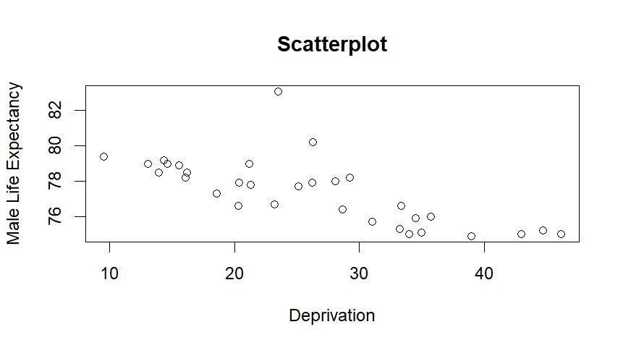
The scatterplot shows the relationship between deprivation and male life expectancy for 32 London boroughs. The red line shows the trend predicted by a simple linear model.
The Spearman correlation was:
- ρ = –0.804
- p-value = 2.94 × 10⁻⁸
Interpretation (non-technical):
This means that higher deprivation is strongly linked to lower male life expectancy. The relationship is very strong and statistically significant. In simple terms, boroughs with more deprivation tend to have shorter average life spans.

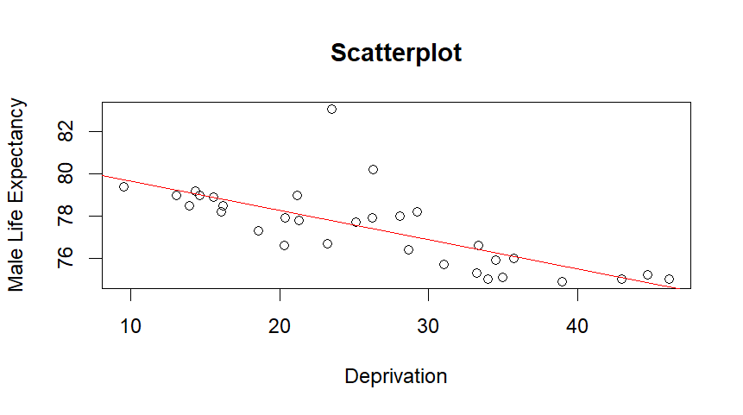
Slope = –0.1387
→ For each 1-point increase in deprivation, male life expectancy drops by about 0.14 years.
p-value < 0.00001
→ This decrease is statistically meaningful.
R² = 0.52
→ Deprivation explains 52% of the variation in male life expectancy.

his section examined whether deprivation predicts male life expectancy. The scatterplot and Spearman correlation showed a strong negative association (ρ = –0.804, p < 0.001), suggesting that boroughs with higher deprivation generally have lower life expectancy. A linear regression confirmed this relationship: each one-point increase in deprivation was linked to about a 0.14-year decrease in life expectancy. The model explained around 52% of the differences between boroughs. Residual plots and normality tests indicated that the model fits well, with no serious violations of assumptions. Overall, deprivation is a major and reliable predictor of male life expectancy in London boroughs.
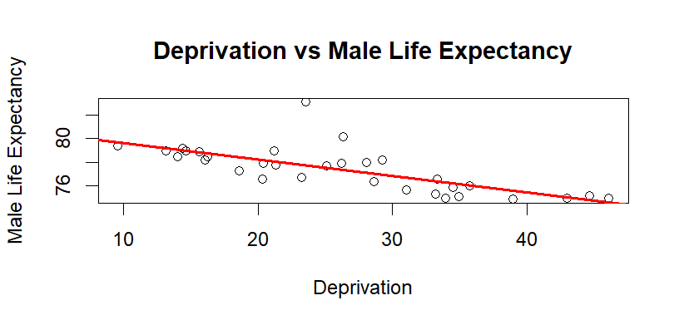

Task 2

Call:
lm(formula = Life_Male ~ Deprivation)
Residuals:
Min | 1Q | Median | 3Q | Max
-1.6092 | -0.6776 | -0.2439 | 0.2342 | 5.3304

Coefficients:
Estimate Std. Error t value Pr(>|t|)
(Intercept) 81.02974 0.67302 120.398 < 2e-16 ***
Deprivation -0.13867 0.02419 -5.733 2.95e-06 ***

Signif. codes: 0 ‘***’ 0.001 ‘**’ 0.01 ‘*’ 0.05 ‘.’ 0.1 ‘ ’ 1

Residual standard error: 1.324 on 30 degrees of freedom
Multiple R-squared: 0.5228, Adjusted R-squared: 0.5069
F-statistic: 32.86 on 1 and 30 DF, p-value: 2.95e-06

A simple linear regression was fitted with male life expectancy as the dependent variable and deprivation as the predictor. The model was statistically significant, F(1, 30) = 32.86, p < 0.001, and explained around 52% of the variance in male life expectancy (R² = 0.52). The fitted regression line shows that male life expectancy decreases as deprivation increases, meaning that districts with higher deprivation scores tend to have lower male life expectancy.

$$\hat{\text{Life_Male}}=81.03-0.139×\text{Deprivation}.$$
The slope for deprivation was significantly negative (β = −0.139, SE = 0.024, t = −5.73, p < 0.001). This means that for every 1-unit increase in deprivation, male life expectancy falls by about 0.14 years on average.

Task 3
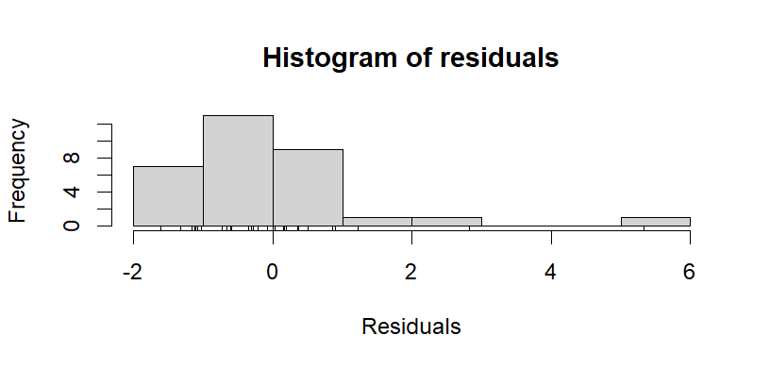
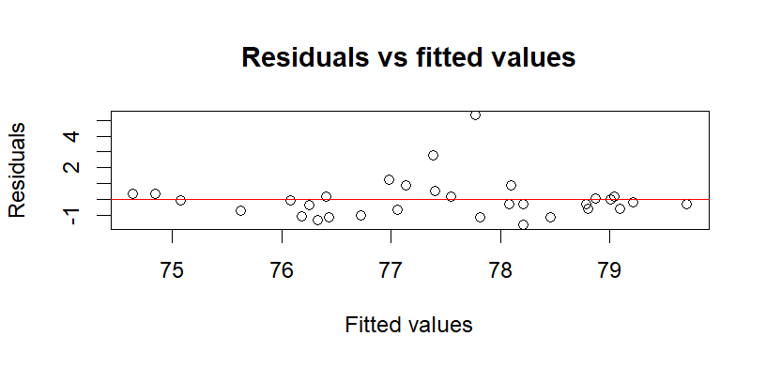

The histogram of residuals shows that most values are clustered close to zero, with a small number of larger positive residuals. This suggests a slight right skew, likely driven by one or two possible outliers.
The residuals vs fitted plot (Figure 3) does not display any clear pattern or curvature, and the residuals are spread fairly evenly around zero. This supports the assumption that the relationship is reasonably linear and that the variance of the residuals (homoscedasticity) is roughly constant.
Normality tests for residuals
ks.test(model1$residuals, "pnorm", mean(model1$residuals), sd(model1$residuals))
D = 0.20279, p-value = 0.1248
shapiro.test(model1$residuals)
W = 0.76574, p-value = 9.856e-06
Normality of the residuals was checked using both the Kolmogorov–Smirnov and Shapiro–Wilk tests. The KS test did not show a significant departure from normality (D = 0.20, p = 0.125), but the Shapiro–Wilk test did suggest some deviation (W = 0.77, p < 0.001).
Taken together with the histogram, this suggests that the residuals are approximately normal, but with some skew caused by a small number of large residuals. Given the sample size and the fact that linear regression is fairly robust to mild departures from normality, the model can still be considered acceptable — though the results should be interpreted with a bit of caution.

Task 4

All 10 predictors
Call:
lm(formula = Life_Male ~ Dom_Build + NonDom_Build + Dom_Gardens +
Greenspace + Smoking + Binge_Drink + Obese + Episodes + Benefits +
Crime, data = London.dis)

Residuals:
Min 1Q Median 3Q Max
-2.02272 -0.44289 0.00305 0.70921 1.38197

Coefficients:
Estimate Std. Error t value Pr(>|t|)
(Intercept) 84.9067214 5.5176720 15.388 6.57e-13 ***
Dom_Build 0.2820230 0.1241387 2.272 0.0337 *
NonDom_Build 0.3465355 0.2185814 1.585 0.1278
Dom_Gardens -0.0553691 0.0534437 -1.036 0.3120
Greenspace 0.0343311 0.0433610 0.792 0.4374
Smoking -0.0748256 0.0652076 -1.147 0.2641
Binge_Drink -0.4092845 0.2385194 -1.716 0.1009
Obese 0.0928405 0.1143755 0.812 0.4261
Episodes 0.0003746 0.0170236 0.022 0.9826
Benefits -0.0332028 0.0061391 -5.408 2.30e-05 ***
Crime -0.0084368 0.0110463 -0.764 0.4535
---
Signif. codes: 0 ‘***’ 0.001 ‘**’ 0.01 ‘*’ 0.05 ‘.’ 0.1 ‘ ’ 1

Residual standard error: 0.9526 on 21 degrees of freedom
Multiple R-squared: 0.8272, Adjusted R-squared: 0.7449
F-statistic: 10.05 on 10 and 21 DF, p-value: 5.84e-06

vif(model2)
Dom_Build NonDom_Build Dom_Gardens Greenspace Smoking Binge_Drink
5.826126 23.190030 4.242418 9.289247 2.135680 7.082530
Obese Episodes Benefits Crime
3.899891 4.169436 3.490845 6.406399
> sqrt(vif(model2)) > 2
Dom_Build NonDom_Build Dom_Gardens Greenspace Smoking Binge_Drink
TRUE TRUE TRUE TRUE FALSE TRUE
Obese Episodes Benefits Crime
FALSE TRUE FALSE TRUE

R² = 0.827, Adjusted R² = 0.745, F(10,21) = 10.05, p ≈ 5.8×10⁻⁶ → very good fit.
Only Dom_Build (p = 0.034) and Benefits (p = 2.3×10⁻⁵) are clearly significant.
sqrt(vif) > 2 for Dom_Build, NonDom_Build, Dom_Gardens, Greenspace, Binge_Drink, Episodes, Crime → strong multicollinearity.
Conclusion: high R² but unstable coefficients; too much collinearity to be a good model for interpretation.
Model 2, which included all ten predictors, achieved a high R² of 0.83, but only Dom_Build and Benefits were statistically significant. Several predictors had √VIF values greater than 2, indicating substantial multicollinearity. Because of this, the model is not well suited for interpreting the individual effects of each predictor, even though it fits the data well overall.
Model 3 – Greenspace, Crime, Smoking, Episodes
Models 3 and 3a – reduced sets of predictors
Call:
lm(formula = Life_Male ~ Greenspace + Crime + Smoking + Episodes,
data = London.dis)
Residuals:
Min 1Q Median 3Q Max
-2.6418 -0.7812 -0.1888 0.6973 3.3464

Coefficients:
Estimate Std. Error t value Pr(>|t|)
(Intercept) 89.400085 3.020137 29.601 < 2e-16 ***
Greenspace 0.043878 0.025460 1.723 0.09625 .
Crime -0.005213 0.008138 -0.641 0.52717
Smoking -0.177092 0.074085 -2.390 0.02407 *
Episodes -0.044568 0.014397 -3.096 0.00454 **
---
Signif. codes: 0 ‘***’ 0.001 ‘**’ 0.01 ‘*’ 0.05 ‘.’ 0.1 ‘ ’ 1

Residual standard error: 1.368 on 27 degrees of freedom
Multiple R-squared: 0.5415, Adjusted R-squared: 0.4736
F-statistic: 7.973 on 4 and 27 DF, p-value: 0.0002226

> sqrt(vif(model3)) > 2
Greenspace Crime Smoking Episodes
FALSE FALSE FALSE FALSE
> #Partial correlations & Model 3a
> # partial correlations to see unique contributions
> pcor.test(Life_Male, Crime, Greenspace) # Life_Male ~ Crime controlling Greenspace
estimate p.value statistic n gp Method
1 -0.02933233 0.8755304 -0.1580274 32 1 pearson
> pcor.test(Life_Male, Greenspace, Crime) # Life_Male ~ Greenspace controlling Crime
estimate p.value statistic n gp Method
1 0.21626 0.2426071 1.192823 32 1 pearson

Call:
lm(formula = Life_Male ~ Greenspace + Smoking + Episodes, data = London.dis)

Residuals:
Min 1Q Median 3Q Max
-2.6361 -0.7323 -0.2256 0.6953 3.5249

Coefficients:
Estimate Std. Error t value Pr(>|t|)
(Intercept) 88.31182 2.47066 35.744 < 2e-16 ***
Greenspace 0.05122 0.02249 2.277 0.03059 *
Smoking -0.18946 0.07077 -2.677 0.01227 *
Episodes -0.04161 0.01349 -3.084 0.00456 **
---
Signif. codes: 0 ‘***’ 0.001 ‘**’ 0.01 ‘*’ 0.05 ‘.’ 0.1 ‘ ’ 1

Residual standard error: 1.354 on 28 degrees of freedom
Multiple R-squared: 0.5346, Adjusted R-squared: 0.4847
F-statistic: 10.72 on 3 and 28 DF, p-value: 7.298e-05

> sqrt(vif(model3a)) > 2
Greenspace Smoking Episodes
FALSE FALSE FALSE
> # relative importance of predictors
> calc.relimp(model3a, type = "lmg", rela = TRUE)
Response variable: Life_Male
Total response variance: 3.556613
Analysis based on 32 observations

3 Regressors:
Greenspace Smoking Episodes
Proportion of variance explained by model: 53.46%
Metrics are normalized to sum to 100% (rela=TRUE).

Relative importance metrics:

lmg
Greenspace 0.1687922
Smoking 0.4577703
Episodes 0.3734376

Average coefficients for different model sizes:

1X 2Xs 3Xs
Greenspace 0.04367634 0.04799786 0.05122375
Smoking -0.29247074 -0.25995405 -0.18946138
Episodes -0.04354081 -0.04278427 -0.04161196

Model 4 – stepwise from high-loading variables

Call:
lm(formula = Life_Male ~ Benefits + Episodes, data = London.dis)

Residuals:
Min 1Q Median 3Q Max
-2.2674 -0.5097 -0.0773 0.4953 3.1776

Coefficients:
Estimate Std. Error t value Pr(>|t|)
(Intercept) 87.773485 1.862490 47.127 < 2e-16 ***
Benefits -0.025528 0.003819 -6.684 2.49e-07 ***
Episodes -0.028578 0.009691 -2.949 0.00624 **
---
Signif. codes: 0 ‘***’ 0.001 ‘**’ 0.01 ‘*’ 0.05 ‘.’ 0.1 ‘ ’ 1

Residual standard error: 1.077 on 29 degrees of freedom
Multiple R-squared: 0.6947, Adjusted R-squared: 0.6737
F-statistic: 33 on 2 and 29 DF, p-value: 3.372e-08

sqrt(vif(model4)) > 2
Benefits Episodes
FALSE FALSE

> calc.relimp(model4, type = "lmg", rela = TRUE)
Response variable: Life_Male
Total response variance: 3.556613
Analysis based on 32 observations

2 Regressors:
Benefits Episodes
Proportion of variance explained by model: 69.47%
Metrics are normalized to sum to 100% (rela=TRUE).

Relative importance metrics:

lmg
Benefits 0.7725658
Episodes 0.2274342

Average coefficients for different model sizes:

1X 2Xs
Benefits -0.02813004 -0.02552817
Episodes -0.04354081 -0.02857761

Histogram of model4$residuals Residuals vs fitted values

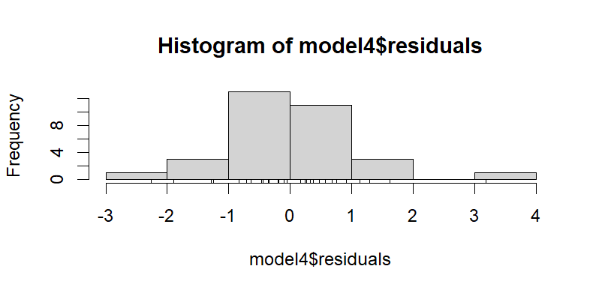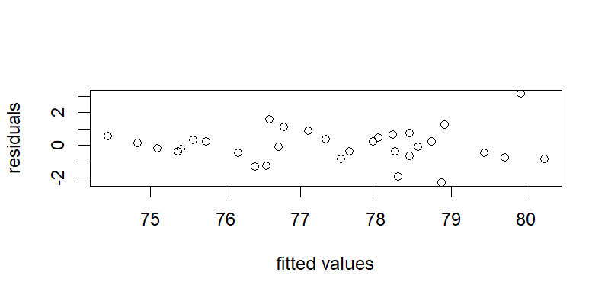

The histogram of residuals for Model 4 is roughly symmetric, and the Kolmogorov–Smirnov test (p = 0.96) shows no evidence of a departure from normality. The residuals-versus-fitted plot also shows no obvious pattern or funnel shape, suggesting that the assumptions of linearity and constant variance are reasonably well met for this model.

Model 5 – stepwise from all 10 predictors

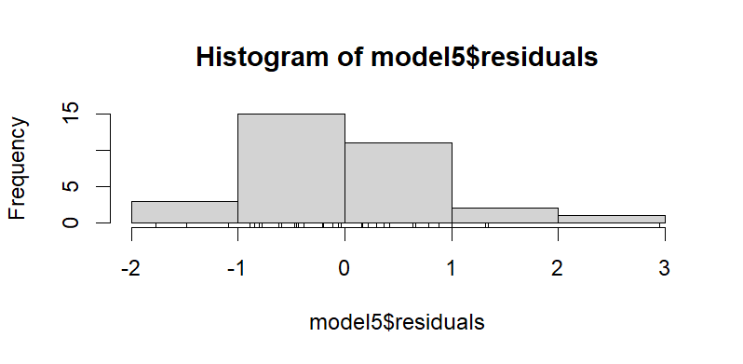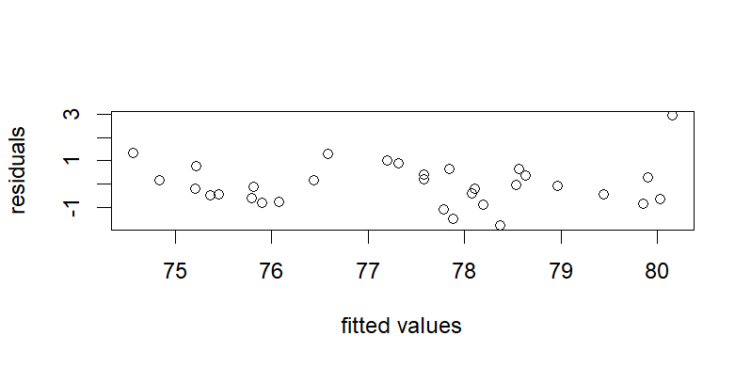

> sqrt(vif(model5)) > 2
Benefits NonDom_Build Smoking
FALSE FALSE FALSE
> calc.relimp(model5, type = "lmg", rela = TRUE)
Response variable: Life_Male
Total response variance: 3.556613
Analysis based on 32 observations

3 Regressors:
Benefits NonDom_Build Smoking
Proportion of variance explained by model: 75.7%
Metrics are normalized to sum to 100% (rela=TRUE).

Relative importance metrics:

lmg
Benefits 0.66407435
NonDom_Build 0.07834407
Smoking 0.25758158

Average coefficients for different model sizes:

1X 2Xs 3Xs
Benefits -0.02813004 -0.0295342 -0.03117245
NonDom_Build -0.06142292 0.1021794 0.19162771
Smoking -0.29247074 -0.2104809 -0.11215613

The residuals appear to be approximately normally distributed (KS test p = 0.98), and the residuals-versus-fitted plot shows no systematic pattern. This indicates that the main model assumptions are well satisfied. Taken together with the relatively high R² (0.76) and low VIF values, this suggests that Model 5 provides a good fit to the data using only a small number of predictors.

Models 6 and 7 – models using factor scores
summary(model6)

Call:
lm(formula = Life_Male ~ fit.data$RC1 + fit.data$RC2 + fit.data$RC3 +
fit.data$RC4)

Residuals:
Min 1Q Median 3Q Max
-2.1736 -0.9078 -0.3432 0.7698 3.8454

Coefficients:
Estimate Std. Error t value Pr(>|t|)
(Intercept) 77.4125 0.2556 302.859 < 2e-16 ***
fit.data$RC1 -0.3586 0.2597 -1.381 0.17862
fit.data$RC2 -1.0562 0.2597 -4.067 0.00037 ***
fit.data$RC3 -0.2000 0.2597 -0.770 0.44786
fit.data$RC4 -0.6719 0.2597 -2.587 0.01538 *
---
Signif. codes: 0 ‘***’ 0.001 ‘**’ 0.01 ‘*’ 0.05 ‘.’ 0.1 ‘ ’ 1
Residual standard error: 1.446 on 27 degrees of freedom
Multiple R-squared: 0.488, Adjusted R-squared: 0.4122
F-statistic: 6.434 on 4 and 27 DF, p-value: 0.0009018

> # Stepwise on the PCs
> model7 <- stepwise(model6, direction = "forward")

Direction: forward
Criterion: BIC

Start: AIC=43.05
Life_Male ~ 1

Df Sum of Sq RSS AIC
+ fit.data$RC2 1 34.584 75.671 34.472
+ fit.data$RC4 1 13.995 96.260 42.174
<none> 110.255 43.052
+ fit.data$RC1 1 3.987 106.268 45.339
+ fit.data$RC3 1 1.240 109.015 46.155

Step: AIC=34.47
Life_Male ~ fit.data$RC2

Df Sum of Sq RSS AIC
+ fit.data$RC4 1 13.9948 61.676 31.394
<none> 75.671 34.472
+ fit.data$RC1 1 3.9870 71.684 36.206
+ fit.data$RC3 1 1.2403 74.430 37.409

Step: AIC=31.39
Life_Male ~ fit.data$RC2 + fit.data$RC4

Df Sum of Sq RSS AIC
<none> 61.676 31.394
+ fit.data$RC1 1 3.9870 57.689 32.721
+ fit.data$RC3 1 1.2403 60.436 34.210
> summary(model7)

Call:
lm(formula = Life_Male ~ fit.data$RC2 + fit.data$RC4)

Residuals:
Min 1Q Median 3Q Max
-2.4507 -1.1124 -0.0876 0.9234 3.2976

Coefficients:
Estimate Std. Error t value Pr(>|t|)
(Intercept) 77.4125 0.2578 300.280 < 2e-16 ***
fit.data$RC2 -1.0562 0.2619 -4.033 0.000366 ***
fit.data$RC4 -0.6719 0.2619 -2.565 0.015748 *
---
Signif. codes: 0 ‘***’ 0.001 ‘**’ 0.01 ‘*’ 0.05 ‘.’ 0.1 ‘ ’ 1

Residual standard error: 1.458 on 29 degrees of freedom
Multiple R-squared: 0.4406, Adjusted R-squared: 0.402
F-statistic: 11.42 on 2 and 29 DF, p-value: 0.0002197

A regression of male life expectancy on the four rotated component scores (Model 6) was significant overall, F(4, 27) = 6.43, p = 0.0009, explaining about 49% of the variance (R² = 0.49). Components RC2 (β = −1.06, p = 0.00037) and RC4 (β = −0.67, p = 0.015) were significant predictors, whereas RC1 and RC3 were not, suggesting that only RC2 and RC4 contribute meaningfully to the model.
Text to describe Model 7
- R² = 0.441, Adjusted R² = 0.402
- F(2, 29) = 11.42, p = 0.00022
- RC2: β = −1.06, p = 0.00037
- RC4: β = −0.67, p = 0.0157
- KS test: D = 0.086, p = 0.96 (residuals approx. normal)
- VIFs all < 2 (no collinearity problems).
- Relative importance:
  - RC2 ≈ 71% of explained variance
  - RC4 ≈ 29%
- ANOVA(model6, model7): F = 1.25, p = 0.30 → no significant loss of fit when dropping RC1 and RC3.

Stepwise selection on the four components produced Model 7, which keeps only RC2 and RC4. This model remains highly significant, F(2, 29) = 11.42, p = 0.00022, and explains about 44% of the variance in male life expectancy (R² = 0.44). Both retained components are significant (RC2: β = −1.06, p = 0.00037; RC4: β = −0.67, p = 0.016). The variance inflation factors are close to 1, confirming that the components are essentially uncorrelated.
A relative importance analysis shows that RC2 contributes roughly 71% of the explained variance, while RC4 accounts for the remaining 29%. An F-test comparing Model 6 with Model 7 (p = 0.30) indicates that removing RC1 and RC3 does not significantly worsen the fit, so the simpler two-component model (RC2 and RC4 only) is preferred.

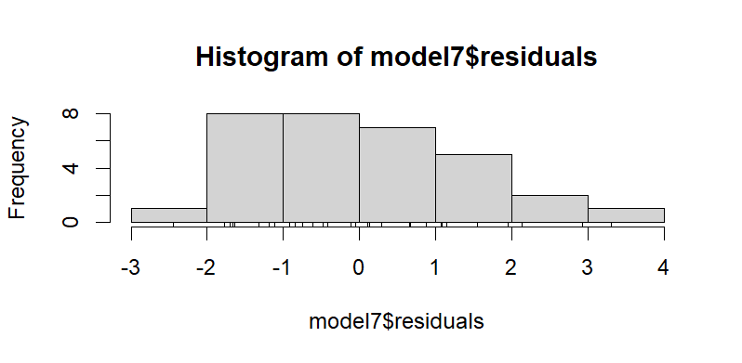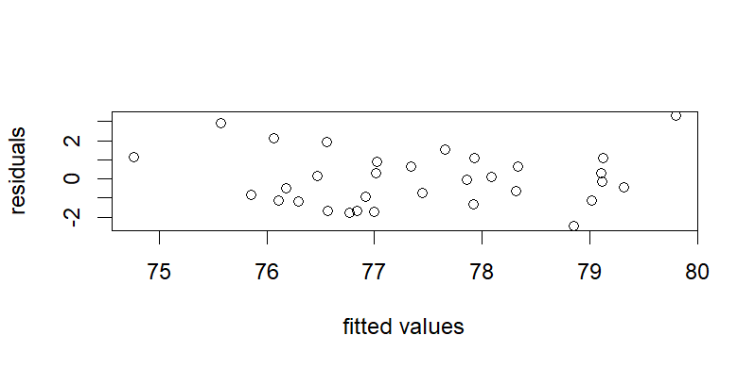

The histogram of residuals for Model 7 is roughly symmetric, and the Kolmogorov–Smirnov test (p = 0.96) provides no evidence against normality. The residuals-versus-fitted plot also shows no clear pattern or change in spread across the range of fitted values. Together, these checks suggest that the assumptions of linearity and constant variance are reasonably well satisfied for this model.

Task 5
(a) Correlation matrix

 | Birth | smoke | ethnic | m_age |  | mwt | low_bwt
birth | 1.00 | 0.03 | 0.00 | 0.64 | 0.30 |  | 0.09
smoke | 0.03 | 1.00 | -0.53 | -0.04 | -0.08 |  | 0.30
ethnic | 0.00 | -0.53 | 1.00 | -0.15 | -0.15 |  | -0.32
m_age | 0.64 | -0.04 | -0.15 | 1.00 | 0.32 |  | 0.09
mwt | 0.30 | -0.08 | -0.15 | 0.32 | 1.00 |  | -0.13
low_bwt | 0.09 | 0.30 | -0.32 | 0.09 | -0.13 |  | 1.00

The correlation matrix suggests that mothers who smoke are more likely to have babies with low birth weight (correlation = 0.30), while babies in ethnic groups 2 and 3 are less likely to have low birth weight than those in group 1 (ethnicity–low birth weight correlation = −0.32). Maternal age is strongly linked to birth order (older mothers tend to have higher-order births, correlation = 0.64) and is moderately related to maternal weight (correlation = 0.32), whereas relationships between most of the other variables are only weak to moderate.

(b) Second round of logistic regression
low_bwt ~ smoke + ethnic + mwt
Coefficients:
 | Estimate | Std. Error | z value | Pr(>|z|)
(Intercept) | 0.329802 | 0.544486 | 0.606 | 0.545
smoke1 | 0.516914 | 0.218877 | 2.362 | 0.018 *
ethnic2 | -0.784194 | 0.325853 | -2.407 | 0.016 *
ethnic3 | -0.845182 | 0.251175 | -3.365 | 0.0008 ***
mwt | -0.006939 | 0.003466 | -2.002 | 0.045 *

In the second-round logistic regression, low birth weight was modelled using maternal smoking, ethnicity and maternal weight as predictors. This model fit the data better than the null model (residual deviance = 568.98 vs 603.79, AIC = 578.98). All three variables – smoking status, ethnicity and maternal weight were statistically significant (p < 0.05), indicating that each is meaningfully associated with the risk of low birth weight. By contrast, birth order and maternal age, which were included in the first-round model, did not show significant effects and were therefore excluded from the final model.

(c) Interpretation of odds ratios

 | OR | 2.5% | 97.5%
(Intercept) | 1.391 | 0.484 | 4.111
smoke1 | 1.677 | 1.091 | 2.577
ethnic2 | 0.456 | 0.234 | 0.847
ethnic3 | 0.429 | 0.260 | 0.699
mwt | 0.993 | 0.986 | 1.000

Smoking (smoke1)
Mothers who smoke have about 1.7 times higher odds of having a low-birth-weight baby than non-smokers (OR = 1.68, 95% CI 1.09–2.58), even after taking ethnicity and maternal weight into account, and because the confidence interval is entirely above 1, this indicates that smoking is a statistically significant risk factor for low birth weight.

Ethnicity (reference category = ethnic group 1)
Compared with ethnic group 1, mothers in ethnic group 2 have much lower odds of having a low-birth-weight baby (OR = 0.46, 95% CI 0.23–0.85), and mothers in ethnic group 3 also have reduced odds (OR = 0.43, 95% CI 0.26–0.70); because both confidence intervals lie entirely below 1, this suggests that belonging to ethnic groups 2 or 3 is associated with a protective effect against low birth weight relative to group 1.
Maternal weight (mwt)
The odds ratio for maternal weight is 0.993 per unit increase (95% CI 0.986–1.000). This means that for each 1- The odds ratio for maternal weight is 0.993 per unit increase (95% CI 0.986–1.000), meaning that for each 1-unit increase in maternal weight the odds of having a low-birth-weight baby fall by around 0.7%; this effect is small but statistically significant at the 5% level.
The intercept odds ratio (1.39) is not usually interpreted in a meaningful way, as it just represents the baseline odds when all predictors are at their reference levels.

Task 6

Based on your second-round logistic regression, the main conclusions are:
• Maternal smoking is a clear risk factor.
Mothers who smoke have about 1.7 times higher odds of having a low-birth-weight baby than non-smokers (OR ≈ 1.68, 95% CI 1.09–2.58), even after adjusting for ethnicity and maternal weight.
• Ethnic groups 2 and 3 are protective relative to ethnicity 1.
Compared with ethnic group 1:
o Ethnic group 2 has OR ≈ 0.46 (around 54% lower odds).
o Ethnic group 3 has OR ≈ 0.43 (around 57% lower odds).
Both confidence intervals are entirely below 1, so these are statistically significant protective effects.
• Higher maternal weight slightly reduces risk.
OR ≈ 0.993 per unit of weight, meaning each 1-unit increase in maternal weight is linked to about a 0.7% decrease in the odds of low birth weight. The effect is small but still statistically significant.
• Birth order and maternal age are not important once these are included.
They were not statistically significant in the first model and were therefore left out of the second model.

